Student guide to Wikis

Table of Contents
Table of Contents 2
What is a Wiki 3
Wikis within GCULearn 3
To Add a Page to a Wiki 4
The Wiki Toolbar 4
Adding Images 4
Uploading a file 5
Creating Links between pages on a Wiki 5
To Edit Information 6
Changing the Page Hierarchy 6

What is a Wiki
A wiki is a website which is developed and formed collaboratively by contributors who can create, review, add, update and edit content.

Wikis within GCULearn
Within GCU Learn Wikis provide staff and students an opportunity to participate collaboratively to produce content by adding to or editing web pages. A record of all changes is kept to keep track of activity within the Wiki. If your programme leader uses a Wiki as part of your assignment process, this tracking will enable them to look at your content and contribution for marking purposes.
To participate in a Wiki, navigate to the section which contains the Wiki by clicking on the button for that section, the module leader will provide information on the location of the link. The page will open displaying the Wiki which will have this icon beside it, Figure 1.
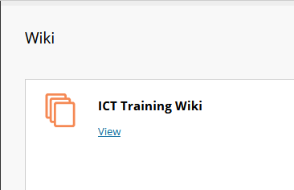
Figure 1: Screenshot of the Wiki icon within GCULearn

To view the Wiki, click on the View link. The first page of the Wiki will be displayed, Figure 2.

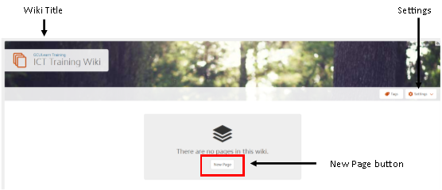
Figure 2: Screenshot of the Wiki Opening Page within GCULearn

To Add a Page to a Wiki
To add a new page to a Wiki, open the Wiki and click on the New Page button. The Add Page dialogue box will open, Figure 3.
New Page Title field
Page content section. Add text/images etc.
Figure 3: Screenshot of a New Page within a Wiki
Enter a page title in the New Page field. Insert content, and Save by clicking on the Save button.
TASK 3:
Add a Page to your Wiki with an appropriate Title.

The Wiki Toolbar
The wiki toolbar allows content to be added to the webpage, including the choice of font type, size and justification. Bulleted/numbered lists can be included and there are options to add links, images, video and files.
Figure 4: Screenshot of the Wiki Toolbar

Adding Images
To add images to the webpage click on the Insert/Edit image command from the toolbar, Figure 5
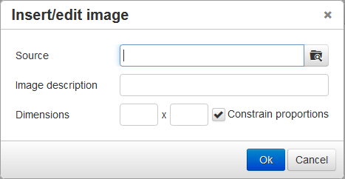
Figure 5: Screenshot of the Insert/Edit image command dialogue box within a Wiki
Navigate to the source of the image and insert. Add an image description and click on the OK button.

Uploading a file
Click on the upload file command from the toolbar, Figure 6
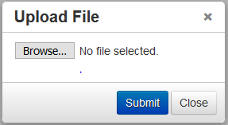
Figure 6: Screenshot of the Upload file command and dialogue box within a Wiki
Navigate to the file and upload. Once uploaded click on the Submit button.

Creating Links between pages on a Wiki
Once content has been added by several contributors the pages may be linked. To do this:
Open the page which has to contain the link. Click on the Insert link command from the toolbar. The Insert link dialogue box will be displayed, Figure 7.
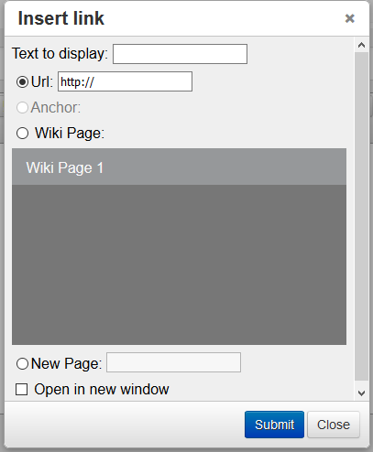
Figure 7: Screenshot of the Insert link command and dialogue box within a Wiki
Click on the Wiki page radio button and then choose the name of the page to be linked from the list.
Click on the Submit button.

To Edit Information
If you wish to Edit the information contained on any of the pages within the Wiki, navigate to that page and click on the Edit button. The page you wish to edit will open enabling you to enter your changes/addition.
Edit button

Figure 8: Screenshot of the Edit button within a Wiki
Note: REMEMBER – only one person can edit a page at the same time. Once you have entered your changes click on Save.

Changing the Page Hierarchy
Pages are initially listed in the order they are created. To change this order, go to Settings and choose page Hierarchy from the menu.
Drag and drop to the position required.

This work is licensed under a Creative Commons Attribution-NonCommercial-ShareAlike 4.0 International License.

