



**Student guide to Padlet**

Table of Contents

Table of Contents 2

What is Padlet? 3

Getting Help with Padlet 3

Opening Padlet 3

Posting to Padlet 4

Editing and Deleting Posts 6

What is Padlet?

Padlet is an application used for making and sharing collaborative content with others. Currently there is no limit to the number of people that can post to a Padlet wall at any one time, so large groups can be involved.

Getting Help with Padlet

These notes do not explain every feature of the program therefore you are expected to make use of the Help facility. To access the Help facility within Padlet click on the ellipses at the top right hand corner of the page … and choose Get help from the menu which will be displayed, Figure 1.

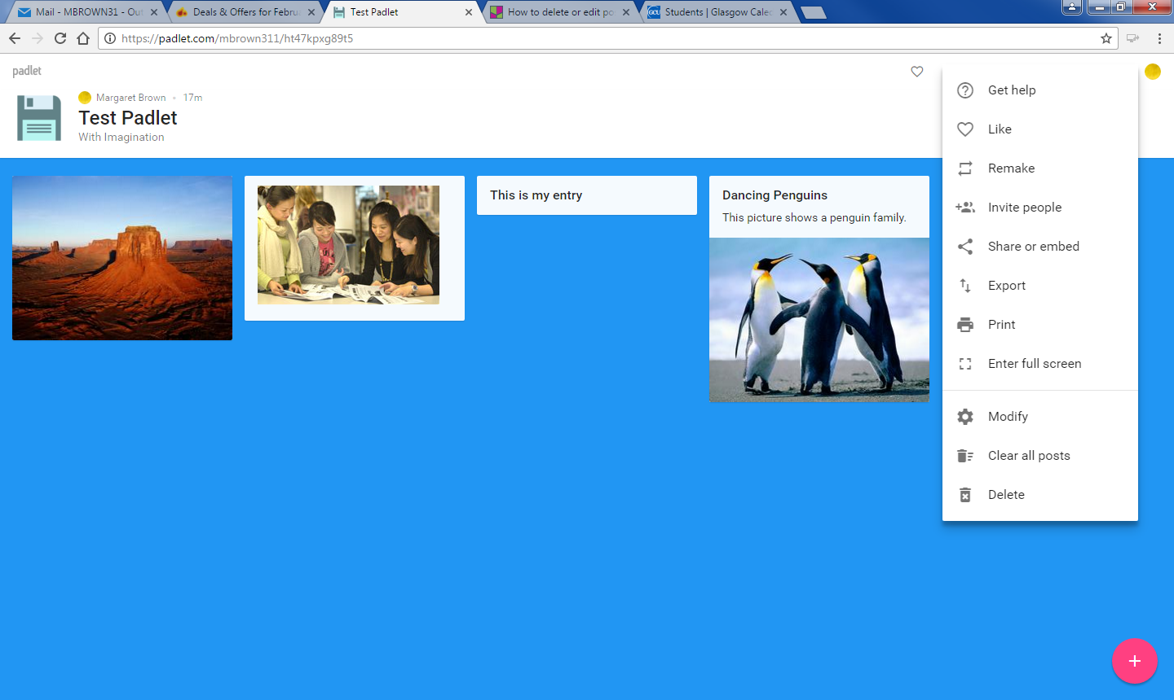

Figure : Get help menu option within Padlet

**This is an image of an exclamation mark indicating that there is important information which should be read. Note:** This icon denotes important information – read it carefully.

Opening Padlet

To join a Padlet session you should click on the link to the Padlet session you wish to join, this will be sent to you by email or embedded within your Module on GCU Learn. The link will be in the format: <https://padlet.com/username/padletid>.

Once you click on the link the Padlet page will be displayed, Figure 2.

Padlet Author, Name and Description

Add Button

Padlet Wall

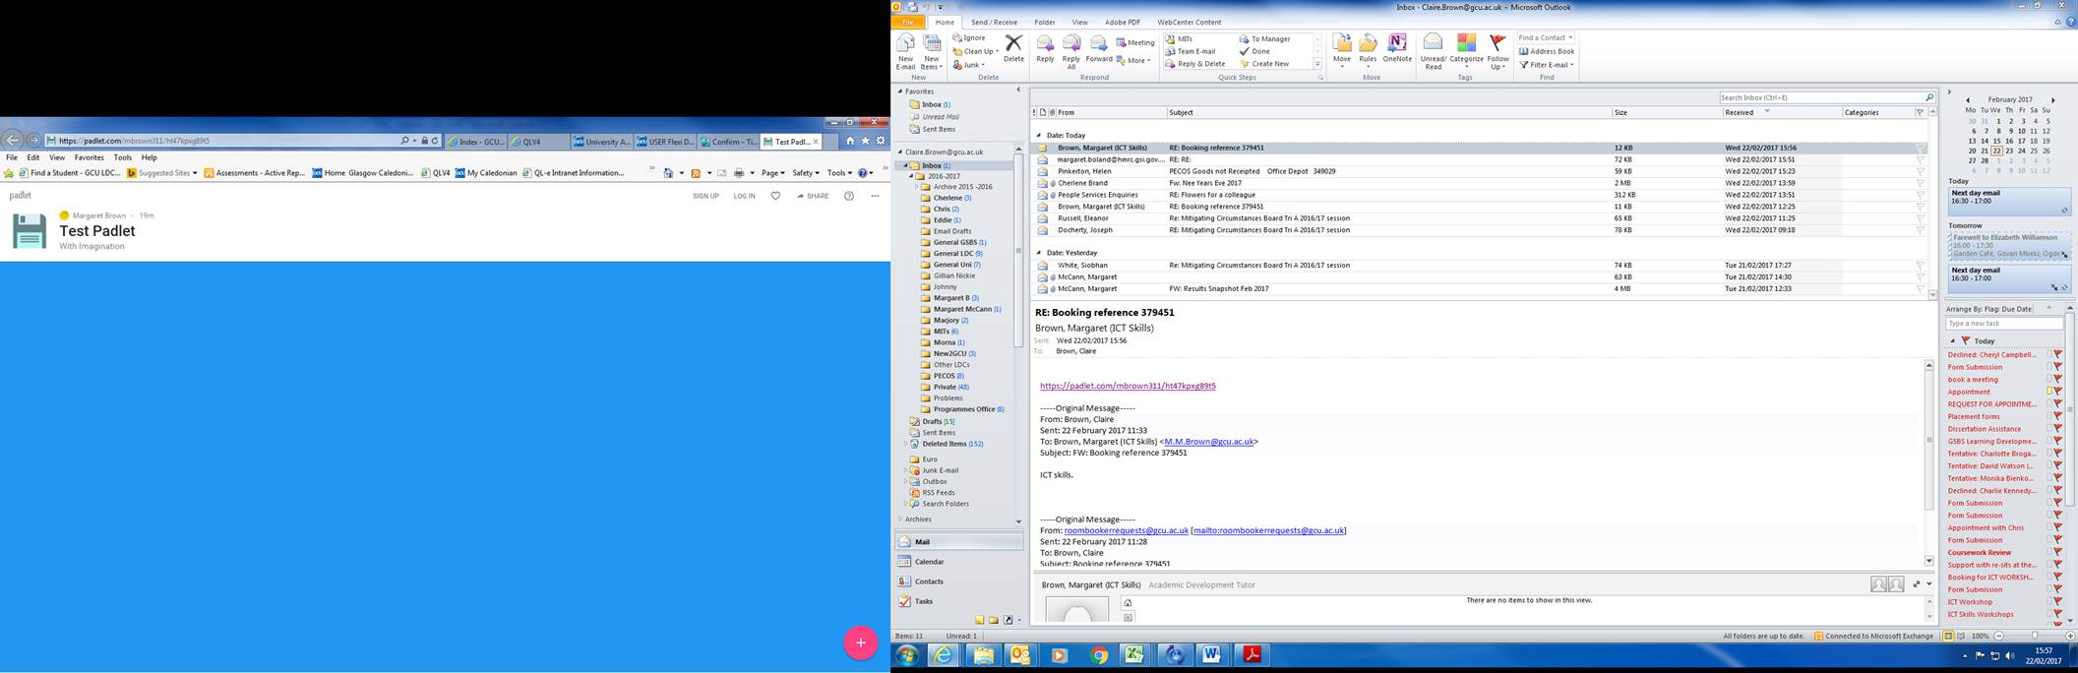

Option Links

Padlet Wall

Figure : Padlet Opening Wall

**This is an image of an exclamation mark indicating that there is important information which should be read. Note:** Remember, Padlet is customisable therefore the wall will have a different look/feel dependant on who created it.

Posting to Padlet

**This is an image of an exclamation mark indicating that there is important information which should be read. Note:** **to get the full experience you should post from a desktop/laptop as there will be limited functionality when using a mobile device:**

There are different ways to post on Padlet:

1. **Click on the Add button** , the + sign becomes a pencil and a text box is displayed for you to enter text, Figure 3.

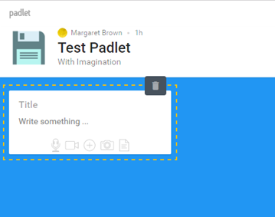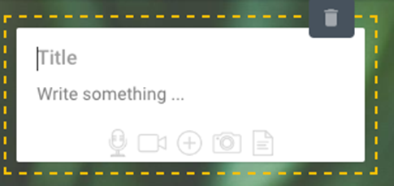

Title

Write directly onto Padlet

Add media

Figure : Text box entry on Padlet Wall

1. **Double click on the Padlet wall**. The text entry dialogue box will be displayed. Enter the required text, or click on the add media section to attach a file. The Add an Attachment panel will be displayed at the right hand side of the wall giving you further options, Figure 4.

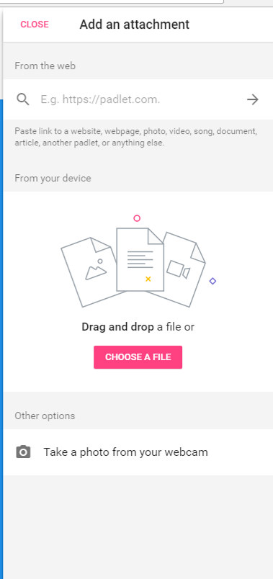

Web address entry field

Drag and Drop or

Browse your device to find a file

Take a photo from your webcam

Figure : Add an attachment panel

**This is an image of an exclamation mark indicating that there is a important information which should be read. Note: If using a mobile device you will only be able to add text and a photo to the Padlet.**

1. **Drag and drop**. To drag and drop, select the file you wish to add to the Padlet from your desktop/laptop and drag it to the Padlet wall, once on the Padlet wall drop the file. The progress of the addition will be displayed at the bottom right hand corner, Figure 5.

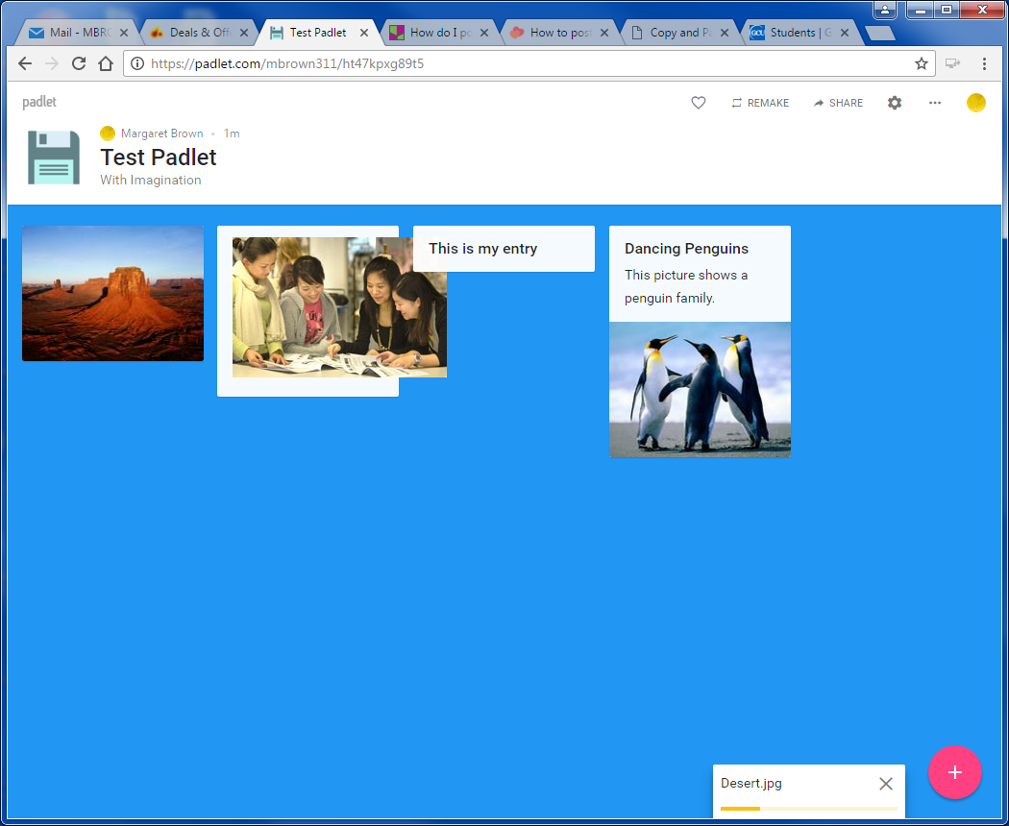

File being added to Padlet wall.

Figure : File being added to Padlet wall after being dragged and dropped.

1. **Copy and Paste** directly to the Padlet Wall. When copying and pasting you click on the Padlet wall and use the Control + V command to paste (Command + V when using a Mac).

Editing and Deleting Posts

To edit or delete a post, click on the post and the editing options taskbar will be displayed. To Edit the post choose the **Pencil Icon** and make the necessary changes. To delete the Post choose the **Trashcan Icon**, a warning dialogue box will be displayed informing you that this action cannot be undone, if you are certain you wish to delete the post choose OK, otherwise choose Cancel from the dialogue box.

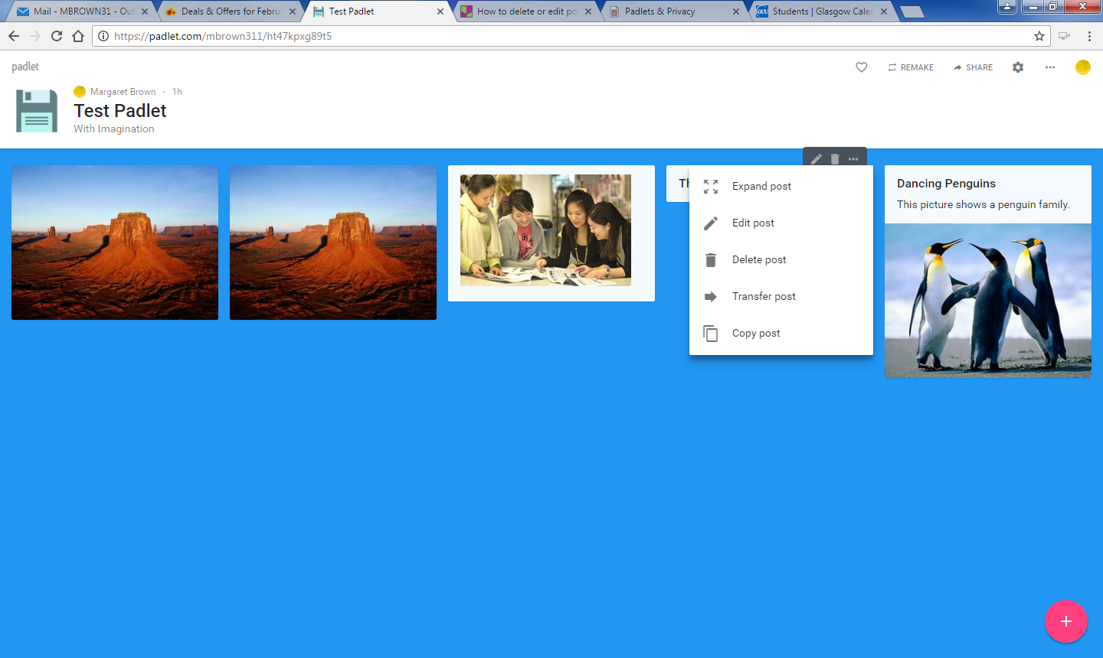

Edit Post, Delete Post

Other Options expanded menu

Figure : Post with Edit mode taskbar displayed.

**This is an image of an exclamation mark indicating that there is important information which should be read. Note: You can only edit or delete your own posts, and this can only be done from the device originally posted from. Therefore, if you posted on your home computer/laptop you will not be able to edit or delete from a mobile device or other computer.**

This work is licensed under a [Creative Commons Attribution-NonCommercial-ShareAlike 4.0 International License.](http://creativecommons.org/licenses/by-nc-sa/4.0/)