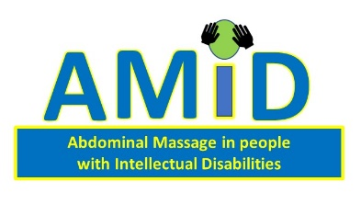

Tailored abdominal massage treatment for constipation in adults with learning disabilities – A Feasibility study and Pilot trial:
INFORMATION ABOUT THE PROJECT AND CONSENTING ON BEHALF OF THE PERSON YOU ARE WELFARE ATTORNEY, WELFARE GUARDIAN OR NEAREST RELATIVE TO
IMPORTANT: Prior to consenting it is important to ensure that you put aside your own feelings and wishes and consider what the past and present, feelings and wishes of the person you are consenting on behalf of, would have been, had they been able to consent for themselves.
Welfare Attorney/Welfare Guardian/Nearest Relative
My name is Jennifer Crockett and I am a researcher. I would like to invite your relative with learning disabilities (LD), or the person with learning disabilities you are welfare guardian or attorney to, to take part in a research project. The research project will help us find out if abdominal (stomach) massage helps people with a learning disability who suffer from constipation to go to the toilet more easily. It will also find out if people with a learning disability are willing to take part in a research project and receive abdominal massage from a carer or by using an abdominal massage belt.
Before making the decision about whether the person wants to take part or not, it is important to know why the research is being done, and what it will involve for the person. Please take time to read this information. Discuss it with other people if you want to.
If there is anything you are not sure about, or if you would like more information, then please do not hesitate to contact me. My telephone number is 0141 331 8712 and my email address is AMID@gcu.ac.uk.
Who is doing this research project?
This research is being conducted by researchers at Glasgow Caledonian University, in collaboration with NHS Greater Glasgow and Clyde
Why is this research being done?
Constipation, which is difficulty going to the toilet to do a ‘poo’ or stool is common in adults with learning disabilities, but there is not a lot of knowledge (information) about the best way to help treat constipation experienced by adults with learning disabilities.
Adults with learning disabilities who have constipation should be assessed and treated. There is knowledge (information) to suggest that abdominal massage may help some people with constipation so they can go to the toilet more easily. The abdominal massage is usually undertaken by a carer (after training) on the patient. In addition, there is also information to suggest that the use of a device to do the massage may be as beneficial as getting a carer to do it. This is called the MOWOOT device and consists of a belt which goes around the abdomen and is connected to a small motor that makes small sections of the belt at the front inflate and deflate at intervals in a clockwise direction
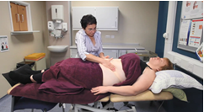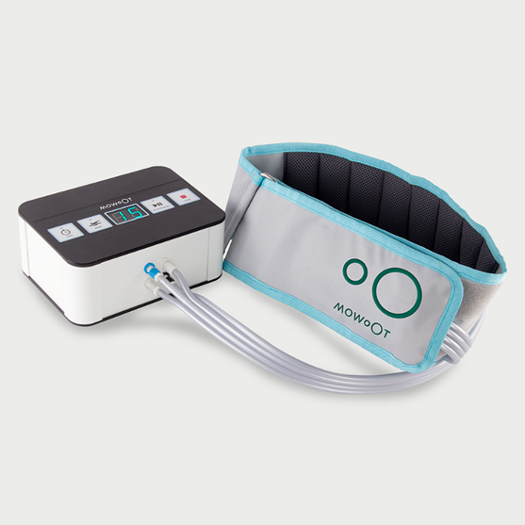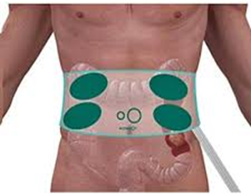
This research project wants to invite 40 adults with learning disabilities and constipation to take part.
What will this research project find out?
The research is being done to find out 1) if people with learning disabilities tolerate the manual or device massage, 2) are carers willing and able to undertake the massage or help with device usage if appropriate, 3) if the questionnaires and bowel diary we want completed are feasible to get completed before and after the abdominal massage 6 week intervention period.
What will the research involve and why do you want my relative, or the person I am welfare guardian or attorney to, to take part?
If your relative/the person you are welfare guardian or attorney to wants to take part in this research project, he/she will be asked to meet me at their home (or anywhere else they choose) along with their carer.

Home visit:
During the home visit, your relative/the person you are welfare guardian or attorney to will be asked questions about his/her health and about their constipation. The person will be encouraged to have a supporter (relative or support worker) with them during this visit to support them.
They, or their carer, will be asked to complete a 7-day bowel diary in which they will record
information such as how many times, if any, they have passed a stool/poo that day. They will
be asked some questions from questionnaires designed to record quality of life in relation
to bowel problems. Following completion, the person with LD will be randomised to either the
group receiving massage or a control group who will continue as before.

After the completion of the bowel diary, and if the person with LD are in the group doing the massage, they and their carer can start the massage. This will take 15-20 minutes per day and should be completed at least 5 out of 7 days per week. The carer/s will have received training in the massage technique and on how to use the device. There is a DVD/Video and written instructions to help. The person with LD and the carer can decide if they want to undertake the manual massage or use the device. If the person with LD are not in that group then they continue doing everything as before
At the end of the 6 weeks of undertaking/not undertaking the massage, your relative/the person you are welfare guardian or attorney to will be asked to complete the bowel diary and the questionnaires once more (with the help of the carers).
Will I have to give my consent?
As you are the Welfare Guardian, Welfare Attorney or nearest relative of the person with learning disabilities who does not have capacity to give informed consent on their own, you will be asked to give your consent to your relative’s/the person’s participation on their behalf. You will be asked to give your consent to both:
1. your relative’s/the person’s participation in the research; and
2. your support (or the support of a supporter e.g. support worker) to enable your relative’s/the person’s participation in the research.
You will also be asked to give your consent, on your relative’s/the person’s behalf, to contact their GP. It will be important for your relative’s/the person’s GP to know they are taking part in this research project.
What will happen to the information provided about my relative/the person I am welfare guardian or attorney to?
The information provided will be kept confidential by me and other members of the research team. We will keep the information safely and securely in a locked filing cabinet at the university. No one will be able to identify your relative/person you are welfare guardian to from the project results.
The information provided about your relative/person will be anonymised and entered on to a computer at the university. No identifiable information will be included. The Data Protection Act 2018 will be adhered to at all times.
Will the research team need to look at the person I care for/support’s medical notes?
No. With your consent on your relative’s/the person’s behalf, we will write to his/her GP, to tell him/her that the person with learning disability is taking part in the study only:

We will not have access to your relative’s/the person’s medical notes at any time.
What will happen if I decide my relative/the person should not take part?
Nothing will happen if you decide your relative/the person you are welfare guardian or attorney to should not take part. It is your decision as their nearest relative/welfare guardian or attorney. You can ask as many questions as you like about the project, and take as long as you need to decide whether they should take part or not.
What are the possible benefits of taking part?
We do not know if abdominal massage will help your relative/the person you are welfare guardian or attorney to, but it could help them to use a toilet more often, and have a more regular bowel habit.
Your relative’s/the person’s participation in this research will help us learn more about the use of abdominal massage in people with LD and if it is a technique they are willing to use.
What are the possible disadvantages and risks of taking part?
The person you care for/support may take part in the abdominal massage and then find that he/she does not like it, or that it is not helping. If so, then he/she is free to stop immediately. If the person with LD is randomised to the control group we want to find out if they are willing to continue in the research. At the end of the study we will offer training to a carer for those in the control group who would like to try the massage.
If those who are in the abdominal massage group and want to continue using it after the study we will encourage the carers to continue with it and/or provide the device.
There should be no adverse effects of using the abdominal massage.
How has the project been funded and ethically approved?
This research project has been funded by the Baily Thomas Charitable Fund. This project has been ethically approved by the national research ethics committee, Scotland A.
What will happen to the results of the research project?
The results will be shared with other researchers, and health professionals working in learning disabilities services and incontinence services, via written reports, which will be published, and presentations. Your relative/the person you are welfare guardian or attorney to will be not identifiable in any published results.
We will send a summary of results to everyone who took part at the end of the research project in 2021.
What will happen if I agree to my relative/the person taking part and then feel unhappy about it, or the way my relative/the person is being treated?
If at any time during the project, you are unhappy about it, or the way your relative/the person are treated, then we will stop.
We do not expect to make you or your relative/the person unhappy in any way, but if we do, you should complain. You should complain to Ms Debbie Donnett, who is the Assistant Head of Governance at Glasgow Caledonian University. Her email address is Debbie.Donnett@gcu.ac.uk and her telephone number is 0141 331 8226.
How can I find out more about this research project?
Please contact me at any time during any stage of this research project. You are welcome to discuss anything at all about the project, or ask questions. I will be happy to answer your questions over the telephone, or if you prefer, visit you at home in person.
Or you can contact Dr Kirsteen Goodman who is the Principal Investigator on the research team. Her telephone number is 0141 331 3516. Her email address is Kirsteen.goodman@gcu.ac.uk
If you want to talk to someone else about the research project – someone who is not part of the research team – you can contact Professor Margaret Maxwell, NMAHP RU Director, Stirling University. Margaret.Maxwell@stir.ac.uk. Telephone 01786467738
Thank you for taking the time to read this project information

