Asssitive Technologies for remote working

# This short guide tells you about some of the useful assistive technologies you can access at home. As a GCU student, you have free access to all of this software, and this guide tells you how to get started.

# Texthelp Read and Write

Read&Write is a literacy support tool that offers help for everyday tasks with tools like reading text aloud, understanding unfamiliar words and proofing written work. All GCU students can download the chrome plugin version of Read and Write which gives you access to almost all of the key features of the software. On campus, you can use the desktop version of Read and Write too.

Here is the link to download Read&Write for Chrome: <https://www.texthelp.com/products/read-and-write-education/>

To activate the Chrome plugin, simply choose to use a Microsoft account, then type in your university email address and password when Read and Write asks you to log in.

## Read and Write Gold for Chrome



# Microsoft Office 365

With your university Office 365 account, you can access Office 365, including Word, Excel and PowerPoint, via your browser. We recommend you use Office 365 in tandem with the Chrome Read and Write plugin mentioned above, so you should use the Google Chrome browser to do this.

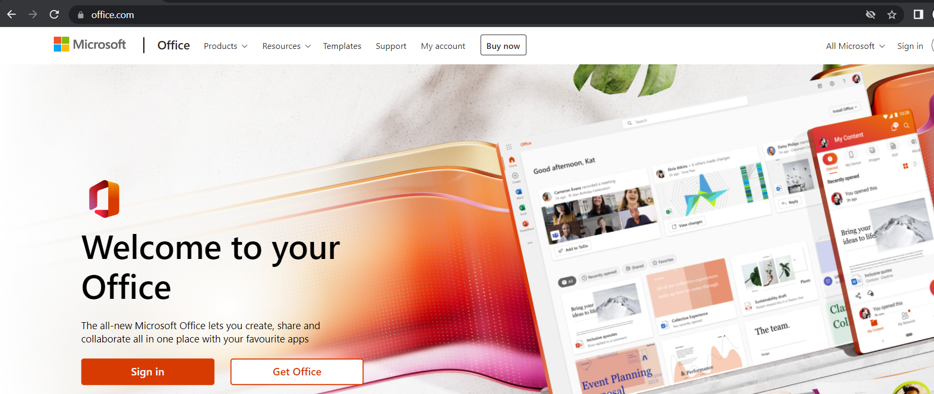

In Chrome, go to <https://www.office.com/> and choose to log in with your university email address and password. From here, you’ll be able to use all of the Office applications straight away at no extra cost.

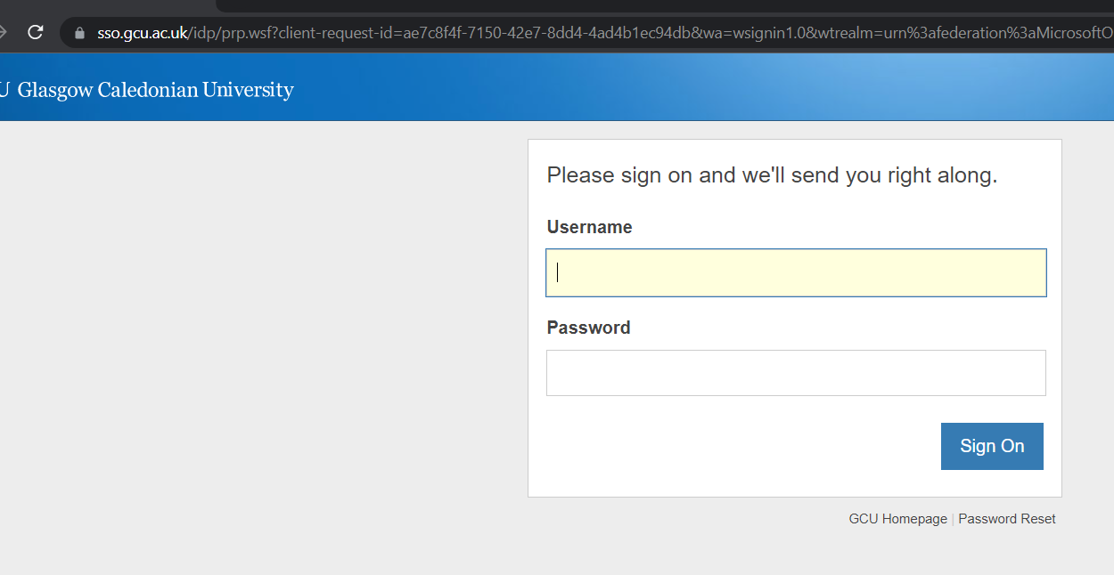 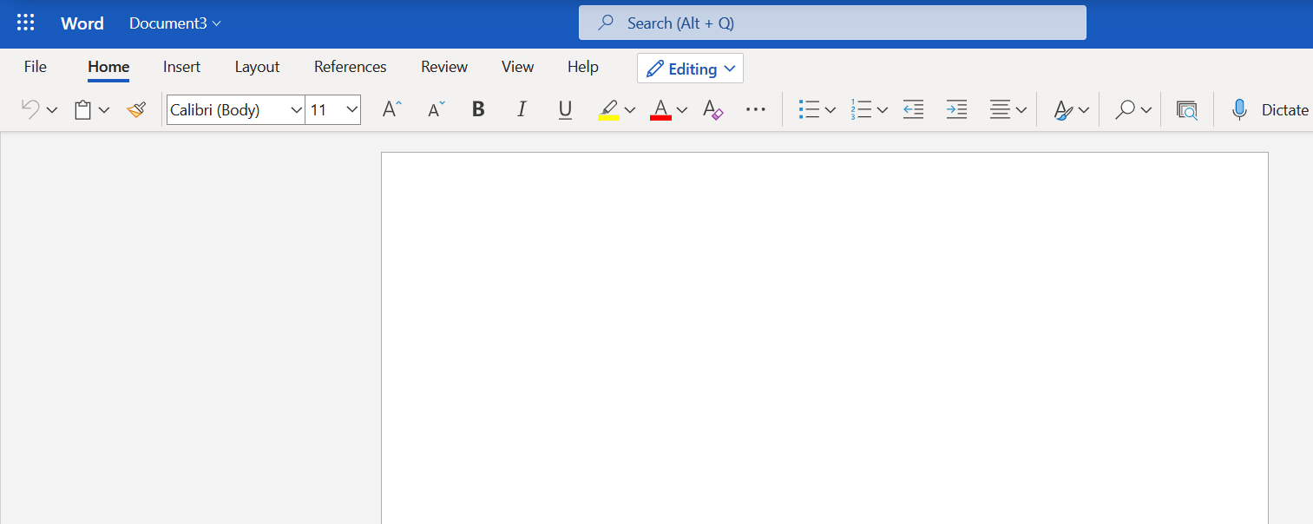

# Microsoft Word Inbuilt Read Aloud Features

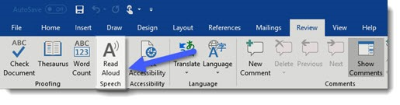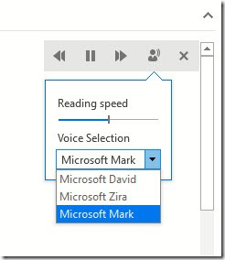

With your student subscription to Microsoft Office 365, you can use Word’s Read Aloud function to read any text in a Word document back to you. Just look for the “Read Aloud” command on the “Review” tab of the Ribbon inside Word.

When you activate this feature, you will see the panel above, where you can adjust options like the reading speed and the voice used.

# Office 365 Immersive Reader

Immersive Reader is a reading enhancement tool available in Office 365 that will work with Word, OneNote and Outlook. Immersive Reader will speak text in a choice of voices and allows you to view the text in a variety of fonts, sizes and background colours. To use the immersive reader in Word:

1. Open your Word document.
2. Select the View tab, then select Immersive Reader
3. Choose the Immersive Reader options that work for you from the ribbon.
4. Once you click in your Word document to read or edit, the Immersive Reader ribbon will minimize.

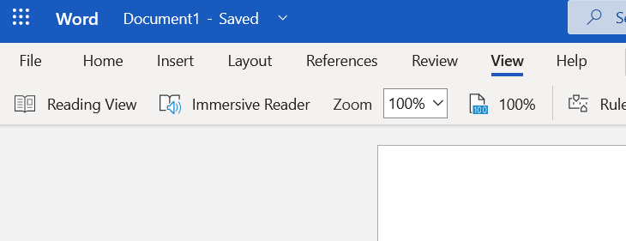

# Microsoft Editor

Microsoft Editor is a feature built into Word and some other Microsoft Office 365 applications. It is meant to improve the quality of your writing, and can point out misspelled words, help with grammar, and offer suggestions for clarity. To use the editor:

1. Open a Word document in Office 365
2. Go to the Home tab.
3. At the very end, click the Editor button.
4. Microsoft Editor will start, and it will scan your document for readability.

# https://www.addictivetips.com/app/uploads/2020/04/Microsoft-Editor-1.jpg

# Mind Mapping with Mind Genius

<https://www.gcu.ac.uk/student/support/it/athomesoftware/>

Mind Genius is the main mind mapping software we recommend at GCU. You can download it by following the instructions at the link above, and it is free for all students studying at GCU.

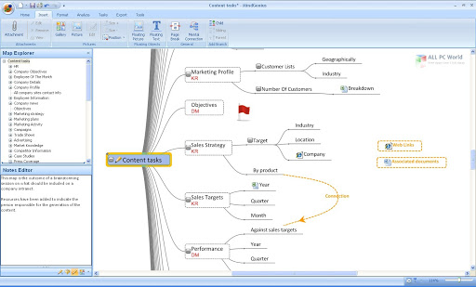

## Mind Mapping on Tablets

MindGenius for iPad: <https://apps.apple.com/gb/app/mindgenius-for-ipad>

More details can be found here: <https://support.mindgenius.com/hc/en-us/articles/206711329-About-the-MindGenius-iPad-app>

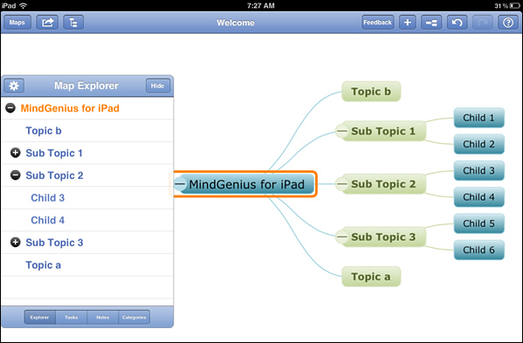

This is a very simple and quick version of the Mind Mapping software we recommend, enhanced with touch screen features to make it intuitive and quick to create a map. You can make a very simple Mind Map on your iOS tablet or phone, then email it to yourself at the touch of a button and use it on the full version of Mind Genius later. At the moment this app is only available on iPads, but there is a link below for an Android app called Simple Mind which is similar

Simple Mind for Android tablet: <http://play.google.com/store/apps/details?id=com.modelmakertools.simplemindfree>

# Mac inbuilt accessibility features

Read Aloud -[**https://support.apple.com/en-gb/guide/mac-help/mh27448/mac**](https://support.apple.com/en-gb/guide/mac-help/mh27448/mac)

Dictation -[**https://support.apple.com/en-gb/guide/mac-help/mh40584/mac**](https://support.apple.com/en-gb/guide/mac-help/mh40584/mac)

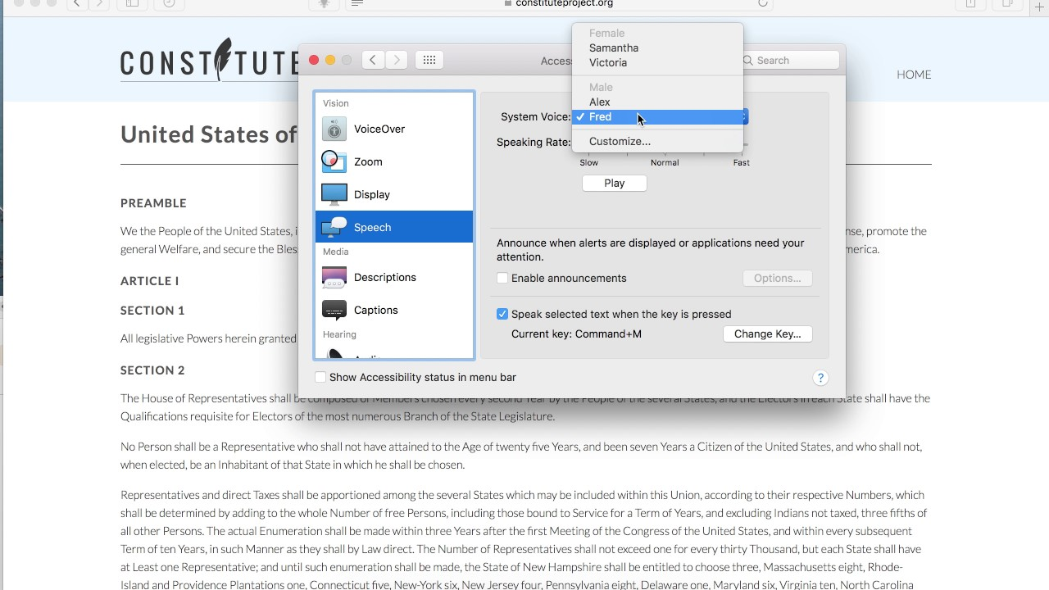

If you use an Apple Mac, there are some basic inbuilt features for both speech-to-text and text-to-speech. Click the links above for more information and instructions on how to get started with these features.

# MyStudyBar

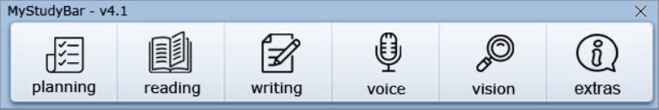

You can install MyStudyBar on your home computer to read text out loud, to check your spelling and grammar and to help you with proof reading. MyStudyBar is similar to Read and Write, but is a little more basic. It is however free for everyone, and you can save it onto a usb drive so you can access it on any computer.. To download MyStudyBar use the link below: <https://www.callscotland.org.uk/mystudybar/>

# Smartphone Read Aloud Apps

For iPhone - <https://itunes.apple.com/gb/app/camscanner-free-pdf-document/id388627783?mt=8>

For Android - <https://play.google.com/store/apps/details?id=com.renard.ocr&hl=en_GB>

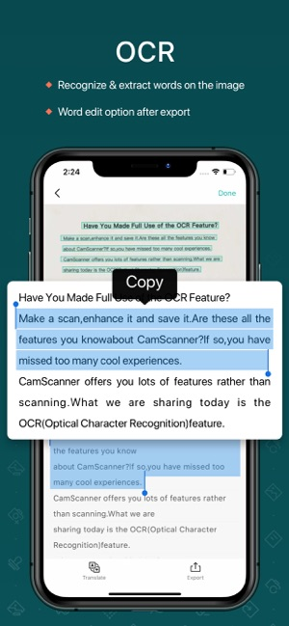 Screenshot of the Text Fairy (OCR Text Scanner) app.

The Apps linked above (*Text Fairy (OCR Text Scanner)* forAndroidand *CamScanner Free* foriPhone) will allow you to take a picture with text in it, and have that image converted to text that you can then edit, save, copy or paste or even have read out loud.