Abdominal massage for constipation in adults with learning disabilities – A Research Study.
PARTICIPANT PROJECT INFORMATION

My name is Jennifer Crockett and I am a Researcher.
Will you help us to find out if abdominal (stomach) massage helps people with learning disabilities to do a poo more easily? To find this out we are doing a ‘research project’. This information tells you about the project. The same information is available on CD/USB stick if you need it.
It is important you know why the research is being done and what it will ask you to do. Then you can decide if you want to take part. Please take time to read this information. Talk about it with other people if you want to.
If there is anything you are not sure about, or if you would like more information, please contact me. My telephone number is 0141 331 8712 and my email address is AMID@gcu.ac.uk Phone me or email me if you would like a copy of this information on CD/memory stick.

Who is doing this research project?
The research is being done by researchers at Glasgow Caledonian University.

Why is this research project being done?
Constipation is difficulty going to the toilet to do a ‘poo’. It is common in adults with learning disabilities. There is not a lot of research or information about the best way to help treat this constipation in adults with learning disabilities.
Adults with learning disabilities who have constipation should be assessed and treated. People think that stomach massage (rubbing the tummy in a certain way) may help some people with constipation so they can go to the toilet more easily.
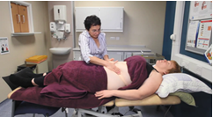
People also think that using a /belt machine to do the massage (MOWOOT) may be as good as getting a carer to do it for you.
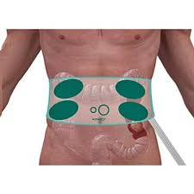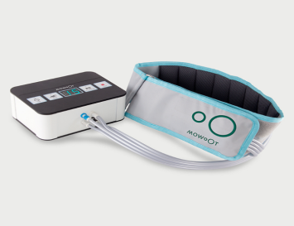

We think that putting some pressure onto the stomach in a special way helps the bowel to work harder to push the food around. This could make it easier to do a poo. You should not have to sit for a long time or push extremely hard for a long time, to do a poo.
The abdominal (stomach) massage needs to be done for about 15-20 minutes every day for a few weeks to see if the constipations gets better.
This research needs 40 adults with learning disabilities with constipation to take part. 30 will be offered the massage, either by a carer or the belt machine, and 10 will not be offered the massage. These 10 people will be shown how to do it at the end of the study.

What will this research project find out?
This research wants to find out if people with learning disabilities want to take part in this kind of study and if they prefer a carer do the massage, or using the belt machine. It is also important that we know if people who are in the group not getting the massage want to continue in the research. Taking part for 6 weeks will give us this important information. We want to do a much bigger research study to find out if the treatment helps with constipation.

Why do you want me to take part?
We want you to take part because you are an adult with a learning disability. A health professional from your local community learning disabilities team thinks you have problems with constipation and that you may like to take part in a study using abdominal massage
We want you to take part if you match the following:
- You have learning disabilities and quite often you find it difficult to go to the toilet to do a ‘poo’
- You have not had surgery to your tummy area during the last year
- You do not have a catheter, that is a tube that goes into your bladder to drain your urine/pee.
- You have a carer who, after training, is willing to either do the massage, help you do the massage, or help you to use the massage belt machine

What will the research project involve?
If you choose to take part one of the research team will meet you at home (or anywhere else you choose) along with your carer.

Home visit:
During the home visit we will make sure you understand the research project and are happy to take part. We will ask you to sign the consent form saying you are happy to take part. A computer will then decide if you are in the group that gets the massage or the group that is shown it later. You will be asked questions about you and your health and also questions about your constipation. We will ask you to complete a simple diary (bowel diary) for the next 7 days where you will record information such as how many times did you do a poo that day.
After these 7 days your carer can start the massage if you are in this group. There is a CD/Video/U-Tube clip and written instructions to help. If you are not in that group, then you continue doing everything as usual.

You will be telephoned every week for the next 6 weeks by one of the researchers to see how you are getting on.
At the end of the six weeks you will be asked to complete the bowel diary again for 7 days and we will phone or visit you at home one last time to ask you some questions about you, your health and your constipation.
We will also ask you and your carer what you think about the abdominal massage.

Will I have to give my consent?
DEMcC
If you choose to take part in this research project, there will be a consent form for you to sign. We will complete the consent form with you at the start of the first home visit.

What will happen to the information I provide?
The information that you provide will be kept private (confidential) by the members of the research team. We will keep the information safe and secure at all times in a locked filing cabinet at the university. No one will be able to know who you are from the project results.
The information that you give will be put on to a computer. The research team will make sure your information on the computer is anonymous. This means that it will not include your name or any other identifiable information about you (for example, your address). The Data Protection Act 2018, which is the law, will be followed at all times.

Will the research team need to look at my medical notes?
No. We will ask for your permission (consent) to write to your GP, to tell him/her that you are taking part in this study only:

We will not look at your medical notes at any time.

What will happen if I choose not to take part?
Nothing will happen if you choose not to take part. You do not have to take part in this research project if you do not want to. It is your choice. You can ask as many questions as you like about the project, and take as long as you need to decide (choose) whether you want to take part or not.

If you choose to take part, you are still free to stop at any time, and you don’t have to say why.
If you choose not to take part, your decision will not affect your future health care in any way.

If you choose not to take part but you are worried about your constipation then you can still contact your GP, or a health professional within your local community learning disabilities team, on your own at any time.

What are the possible benefits of taking part?
We do not know if abdominal massage will help you, but it could help you to go for a poo more often and more easily.

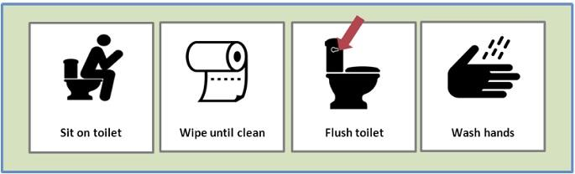

What are the possible disadvantages and risks of taking part?
You might be chosen to be in the group doing the massage then find that you don’t like it, or that it is not helping you. If you find that you don’t like it, or do not think it is helping, then you are free to stop at any time. However, it can take several weeks to show any improvement.
We do not expect the abdominal massage will harm you at all. You may notice more noise and wind from your tummy and bottom but this is a good thing.

How has the research project been funded?
This research project is being paid for by the Baily Thomas Charitable Fund.

Has ethical approval been granted for this research project?
Yes. This research project has been ethically approved by the Scotland A Research Ethics Committee.

What will happen to the results of the research project?
We will share the results (what we found out) with other researchers, and health professionals working in learning disabilities services and incontinence services.

We will send a summary of the results to everyone who took part at the end of the research project in 2023.

The results will be written into reports, which will be published. No one who reads the report will know that it was you who took part.

What will happen if I take part and then feel unhappy about it, or the way I have been treated?
If at any time during the project you feel unhappy about it, or the way you are being treated, then we will stop.
We do not expect to make you unhappy in any way, but if we do, you should complain. You should complain to Ms Debbie Donnett. Debbie is the Assistant Head of Governance at Glasgow Caledonian University. Her email address is Debbie.Donnett@gcu.ac.uk. Her telephone number is 0141 331 8226.

How can I find out more about this research project?
Please contact us if you are interested in taking part in this research project.
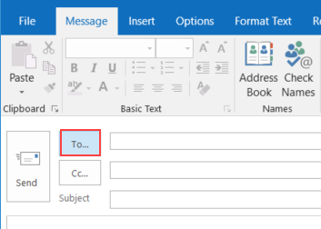
Please contact one of us at any time during any stage of this research project. You are welcome to discuss anything at all about the project, or ask questions. We will be happy to answer your questions over the telephone, or if you prefer, visit you at home in person.

Contacts
Dr Kirsteen Goodman. Kirsteen is the Principal Investigator on the research team. Her telephone number is 0141 331 3516. Her email address is Kirsteen.goodman@gcu.ac.uk
Jennifer Crockett is the researcher who will speak with you the most.

If you want to talk to someone else about the research project – someone who is not part of the research team – you can contact Professor Margaret Maxwell, NMAHP RU Director, Stirling University. Margaret.Maxwell@stir.ac.uk. Telephone 01786467738

Thank you for taking the time to read this project information

