Tailored abdominal massage treatment for constipation in adults with learning disabilities – A Feasibility study and Pilot trial.
MAIN CARER PROJECT INFORMATION LEAFLET
My name is Jennifer Crockett and I am a Researcher.

We would like to invite you to take part in a research project. This information tells you about the project.

Before you choose if you want to take part or not, it is important you know why the research is being done. What it will involve (ask you to do). Please take time to read this information. Talk about it with other people if you want to.

If there is anything you are not sure about, or if you would like more information, please contact me. My telephone number is 0141 331 8712 and my email address is AMID@gcu.ac.uk Phone me or email me if you would like a copy of this information on CD.
Who is doing this research project?
The research is being done by researchers at Glasgow Caledonian University.

Why is this research project being done?
Constipation, which is difficulty going to the toilet to do a ‘poo’ is common in adults with learning disabilities (LD), but there is not a lot of knowledge (information) about the best way to help treat constipation experienced by adults with learning disabilities.
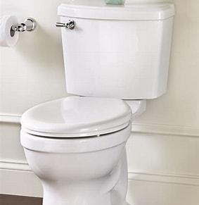

Adults with learning disabilities who have constipation should be assessed and treated. There is knowledge (information) to suggest that abdominal massage may help some people with constipation so they can go to the toilet more easily.
There is also knowledge (information) to suggest that the use of a device to do the massage may be as beneficial as getting a carer to do it for you.
This research wants to invite 40 adults with learning disabilities with constipation to take part. 30 will be offered the abdominal massage, either by a carer or the device, and 10 will not be offered the massage. However, they will be shown how to do it at the end of the study.
What will this research project find out?
This research wants to find out if people with LD are willing to take part in such a study and if they are more willing to let a carer do the massage, or would rather use the device. It is also important that we know if those who are in the group not getting the massage are willing to continue in the research. Taking part for 6 weeks will provide us with this important information before we undertake a much larger study which we need to do to find out if it helps with constipation.

Why do you want me to take part?
Health professionals from your local community learning disabilities team has identified that a person with a LD which you help to care for is eligible to take part in this study. As a carer/support worker for the person with LD you will need to help them to take part in the study. This help may include:
- Being present when the researcher tells the person with LD about the research
- Assisting the person with LD to understand the research and what it involves
- Assisting the person with LD to complete the 7-day bowel diary and complete the questionnaires once before the project starts and then after the six weeks of intervention.
- Identifying other carers or support workers who may also need to be involved in the research
- Understanding that the person with LD who you are caring for will be allocated to either having the massage or not having the massage. Those having the massage will be offered the manual massage or using a device called MOWOOT. Those allocated to no massage will be asked to continue with everything else as normal.
- Undertaking some training in performing the massage either manually or using the MOWOOT device. This training may last 1-2 hours. There is also written instructions and a video of the massage to help.
- If you want the researcher/trainer will help you with the first few times you do the massage or use the device
- Telephone support will be available
- The massage needs to be done at least five out of seven days during the week, and the project lasts for 6 weeks. Each session takes about 15-20 minutes. As the main carer or support worker you may have to develop a rota of those who can help with the massage for the 6 weeks of intervention.
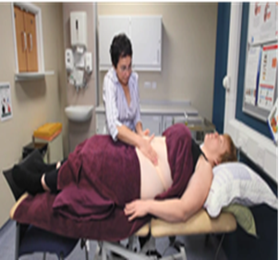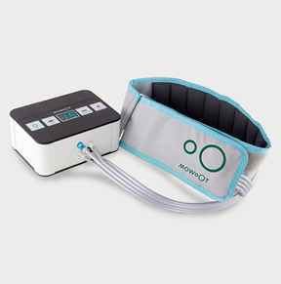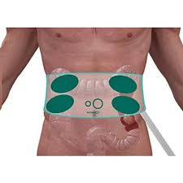

What will the research project involve?
If you choose to take part we will meet you and the person with LD at their home or anywhere else you choose that is suitable.

Home visit:
During the home visit, we will make sure you understand your role in the research project and ask you to sign the consent form to confirm you are happy to take part. We will talk to the person with LD about the research and, if they are capable, get them also to sign a consent form. If they do not have capacity then their relative or person with legal attorney will complete the consent form.
Once the consent forms are signed then a computer will decide if the person with the LD are in the group that gets the massage or the group that is shown it later. We will also ask some questions about the health of the person with LD and complete some questionnaires about their quality of life and bowel function. We will ask for a simple bowel diary to be kept for the next 7 days – you may need to help with this. In the bowel diary we ask that the number of times the person with LD goes to the toilet for a ‘poo’ is recorded, approximately how long it takes and if possible what it looks like. There is a chart to help with this description.
We will arrange a separate time for some training in the massage for you and potentially other carers/support workers involved in the project. We will ty and do this at a suitable time and location for everyone. You will be given access to a video/u-tube clip and leaflets showing how to do the massage and also how to use the MOWOOT device.
The manual massage involves using several different massage techniques over the persons abdomen working from the left side, across and down the right side. It is not difficult to do but like most things might need a bit of practice. The MOWOOT device is a belt which goes around the persons abdomen and is connected to a box which is connected to electricity. When turned on it gives a pulse sensation at 4 areas again going from the left to the right side of the abdomen.
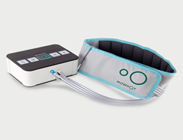
The idea of the massage is to stimulate the bowel to contract more strongly thus moving the food along the bowel more quickly.
If the person you care for is randomised to the control group then there is no massage or any other additional intervention, but they do have to complete the bowel diary and questionnaires. We do not want participants to change their medication if at all possible during the 6 weeks.
We will be available by telephone or virtually if you have any problems at any point.
We will telephone you or the person with LD every week during the 6 weeks to see how you are getting on.
At the end of the 6 weeks we will ask you to help to complete the 7-day bowel diary as well as the questionnaires. We also would like to ask you some questions about how you felt the research project went and about the different methods of massage you experienced. This can be done over the phone or at home (for example, when we collect all the bowel diaries and the MOWOOT device (if applicable).

Will I have to give my consent?
If you choose to take part in this research project, there will be a consent form for you to sign.
What will happen to the information provided by the person with LD?
The information will be kept confidential by the members of the research team. We will keep the information safe and secure at all times in a locked filing cabinet at the university. No one will be able to know who the person with LD is from the project results.
The information will be entered on to a computer. The research team will make sure the information on the computer is anonymous. The Data Protection Act 2018, which is the law, will be adhered to at all times.

What will happen if I choose not to take part?
If you choose not to take part we would ask you to find out if there is another carer or support worker who would help the person with LD to take part. You do not have to take part in this research project if you do not want to. It is your choice. You can ask as many questions as you like about the project, and take as long as you need to decide (choose) whether you want to take part or not.
If you choose to take part, you are still free to withdraw (stop) at any time, and you don’t have to say why.
If you choose not to take part, your decision will not affect the health care of the person with LD or your capacity as their carer or support worker.
.
What are the possible benefits of taking part?
We do not know if abdominal massage will help the person with LD, but it could help them to pass a stool/poo more often and more easily.
Taking part will also help us learn more about undertaking abdominal massage in people with LD and if they are willing to take part in such a project.

What are the possible disadvantages and risks of taking part?
It may take a little bit of extra time for you to take part in the project especially if the person you care for is randomised to the intervention group i.e. to have the massage. All participants will need help to complete the bowel diary and questionnaires. The person with the LD might be chosen to be in the group getting the massage. They can either have the manual or device massage but they may not like it and if that is the case then they can stop having it. However, it can take several weeks to show any improvement.
We do not expect the abdominal massage will harm the person with LD. There may be more noise and wind from the tummy and back passage but this only indicates some benefit.

How has the research project been funded?
This research project is being funded by the Baily Thomas Charitable Fund.

Has ethical approval been granted for this research project?
Yes. This research project has been ethically approved by the Scotland A Research Ethics Committee.

What will happen to the results of the research project?
We will share the results (what we found out) with other researchers, and health professionals working in learning disabilities services.

We will send a summary of the results to everyone who took part at the end of the research project in 2023.

The results will be written into reports, which will be published. You will not be identifiable in any published results.

What will happen if I take part and then feel unhappy about it, or the way I have been treated?
If at any time during the project you feel unhappy about it, or the way you are being treated, then we will stop.

We do not expect to make you unhappy in any way, but if we do, you should complain. You should complain to Ms Debbie Donnett. Debbie is the Assistant Head of Governance at Glasgow Caledonian University. Her email address is Debbie.Donnett@gcu.ac.uk. Her telephone number is 0141 331 8226.

How can I find out more about this research project?
Please contact me if you are interested in taking part in this research project.
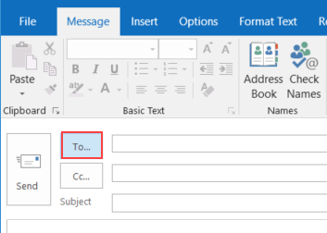
Please contact us at any time during any stage of this research project. You are welcome to discuss anything at all about the project, or ask questions. We will be happy to answer your questions over the telephone, or if you prefer, visit you at home in person.
Contact details
Dr Kirsteen Goodman. Kirsteen is the Principal Investigator on the research team. Her telephone number is 0141 331 3516. Her email address is kirsteen.goodman@gcu.ac.uk

Jennifer Crockett Is the person you will have most contact with. Her number is 0141 331 8712 And email is AMID@gcu.ac.uk

If you want to talk to someone else about the research project – someone who is not part of the research team – you can contact Professor Margaret Maxwell, NMAHP RU Director, Stirling University. Margaret.Maxwell@stir.ac.uk. Telephone 01786467738
Thank you for taking the time to read this project information

