How to Apply to Discretionary & Childcare Funds on “MY PORTAL”

To apply for Discretionary and Childcare funds you must be registered and attending your course and have received the 1st instalment of your Student Loan/Bursary (if applicable) into your bank account.
This year you will be required to make separate applications if applying to both the Discretionary Fund and Childcare Fund. You will apply through your Student Portal.

Please enter your student Portal after registration using your university user name eg jblogg200@.

How to find the discretionary and childcare application form

- First you need to click on the ‘My finance’ button which will be on the left-hand side when you first log into your student portal
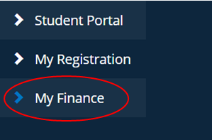

After this, please ensure your bank account details are up to date on the university system by clicking ‘view my bank details’ using the box on the right-hand side.
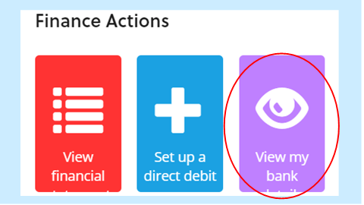
If your application is successful, you will only be able to receive an award if your bank details are up-to-date on the university system.

Once you click ‘view my bank details' you will be given the option to update your bank details as shown below. Please make sure you fill in both the options to receive a ‘Student Discretionary Payment’ and to receive monies from GCU via ‘BACS Payment’ as shown below:
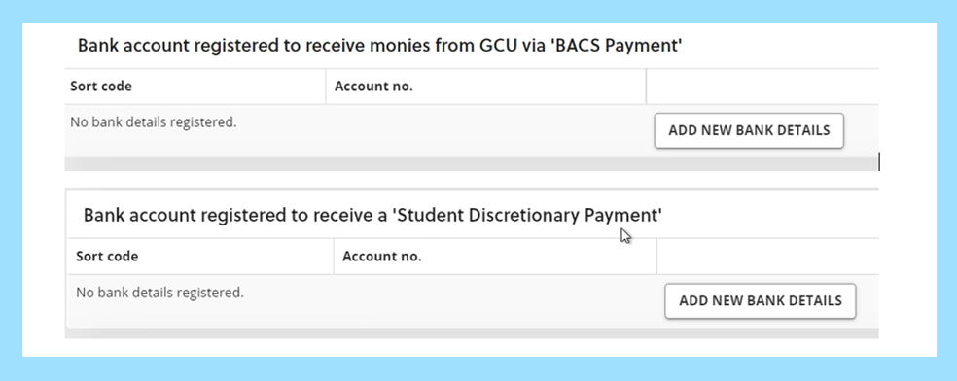
You will then get a verification email from finance, this may be time limited so please verify as soon as you get the email or your bank details will not be updated.
If this has not been updated, you will not receive any award made to your bank account.

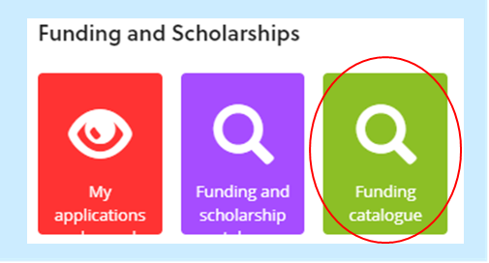
- Once you have confirmed your bank details go back to the ‘My finance’ tab then click on the Funding catalogue box at the bottom right-hand side of the page.

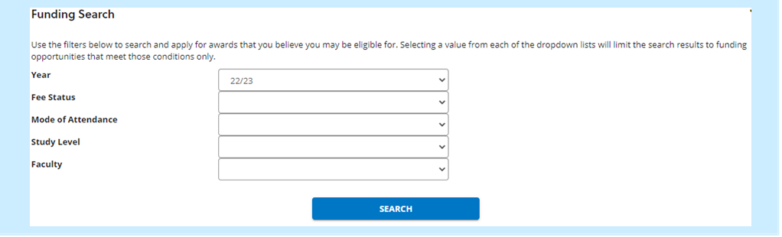
- A new page will appear asking you to confirm your Fee Status, Study Level and Mode of Attendance

- Once you have filled this in, you will see a list of Funds you may be eligible to apply to. Click on the “Apply” button to select the Fund you wish to apply to.

Applying to the Discretionary Fund

- You will see a screen with information about the Fund. Click the blue “Start Application” button at the bottom of your screen. You will see a screen with different sections that will be either green or yellow. You will need to complete all the yellow sections before your application can be submitted. Please note that to complete each section you do not click on the boxes at the top of the page but must select each section from the drop-down list below and then complete each section.
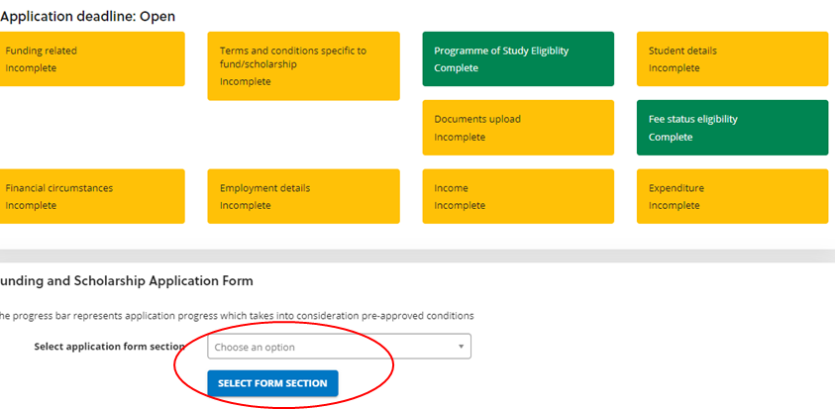

Once fully completed each section will turn from yellow to green. If you have applied for a Fund that you are not eligible to apply to, at least one box will be red and it will tell you that you are not eligible.

Completing each Section

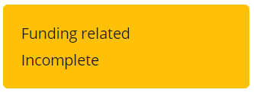
Funding related
Please select your answers from each dropdown menu. Each box must be filed out so if not applicable please put ‘N/A’. Once completed, press the next button.
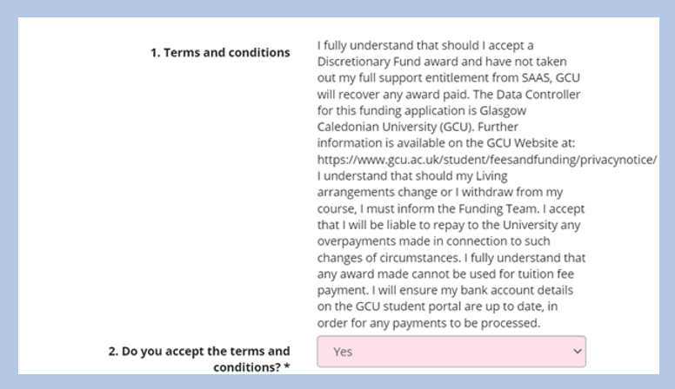
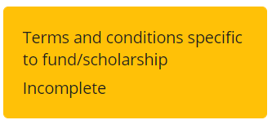
Terms and Conditions
For this section please read and select yes to confirm you understand and agree.

Student Details
All Boxes must be completed. For this section, if you do not have children please enter 0 and then ‘N/A’. Once completed, press the next button.
Document Upload
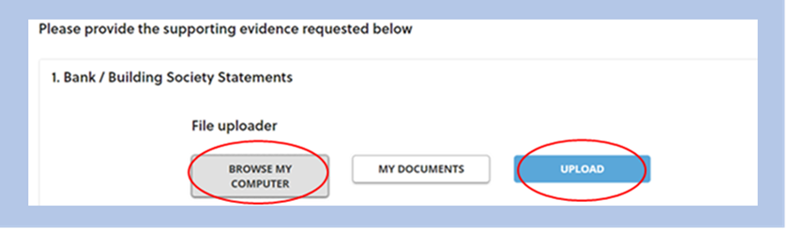
For this section upload all documents relevant to you- Remember to click the ‘Browse My Computer’ and then the ‘Upload’ button to upload your documents successfully.

Essential Guidance on document uploading
Bank or credit card statements - you can download copies of bank or credit card statements as pdfs from most online banking accounts. Mobile apps sometimes do not give this option, so you may need to log into your online banking via a website, instead of relying on a mobile app.
Don't go from "current transactions" as this rarely produces a statement. Look for "statements" or go to historical transactions and go back three months. Statements (for example, something that "looks" like a posted version with name address, account details and so on) are only produced once every month so if you can't get one for this month, last month's will be there somewhere.
SAAS award letter - this can be downloaded as a pdf from your SAAS account. If you can’t find it and need to request a copy from SAAS, you can email SAAS asking for a copy of your 2022-23 Award notice. Whilst the SAAS email response says a response can take up to 28 days, students requesting an award notice usually receive this within a few days
Evidence of accommodation costs – this can be a copy of your tenancy agreement or, if you are living at home, a letter from the homeowner confirming the amount you pay in ‘digs’. Your tenancy agreement should show the address, your name, landlord’s name, dates of tenancy and monthly rent. A letter from the homeowner for ‘digs’ must have their name, signature and contact telephone number.
Timetable- Please provide a copy of your timetable for the current trimester. If you are on placement please provide a timetable or email confirmation of your placement days/weeks from the University or placement staff.

Financial Circumstances
For this section please fill out all the boxes. If questions 3 and 4 are not applicable to you then put ‘N/A’ and then ‘0’. For question 5 state in detail the circumstances which have contributed to your financial hardship. Please note this question has a 2000-character limit.
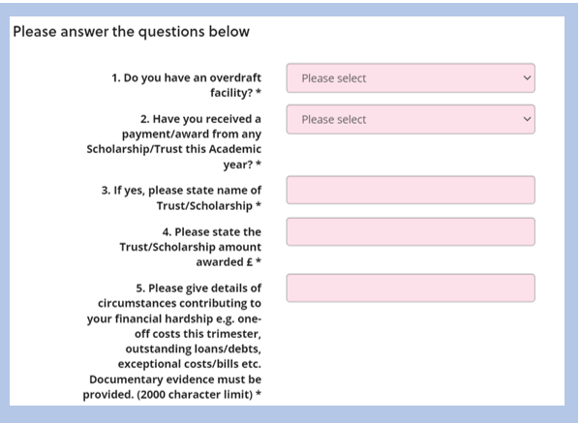

Employment Details
Please fill out all the text boxes, for any which are not applicable enter ‘N/A’. The ‘hours and income per month’ sections require a number even if 0.

Income- Monthly
Please fill out all the sections- for any not applicable sections please enter 0 then next.

Expenditure- Monthly
Please fill out all the sections- for any not applicable sections please enter 0 then next.

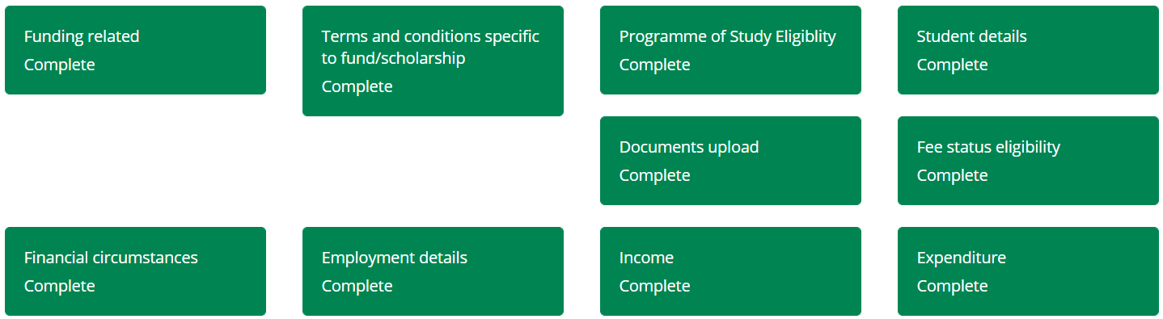
Once all sections are filled out, they should turn green, as pictured below:

Final step Submit
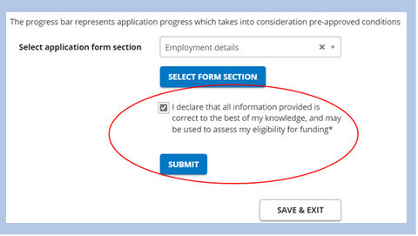
Once all sections are green, please tick the declaration and then click submit and complete.

Please note that once submitted you cannot go back into your application.

You should then receive an email from the Funding Team, confirming receipt of your application. Once received, the Funding Team will assess your application.
If there are any documents missing, or we require further information, you will receive an email to inform you of this. Please follow the guidance in the email you receive on how to submit the required evidence/information.
If your application is successful, you will receive an email giving details of your award and an estimated timescale for you to receive payment.
If your application is refused, you will receive an email giving the reason for this refusal.

Applying to both the Discretionary & Childcare Fund
If applying for both Discretionary Fund and Childcare Fund, you will need to complete both application forms. Once your documents have been uploaded for one application, they will be available for you to upload again under the “My Documents” button for any other applications you make for the same academic year.

Applying to the Childcare Fund

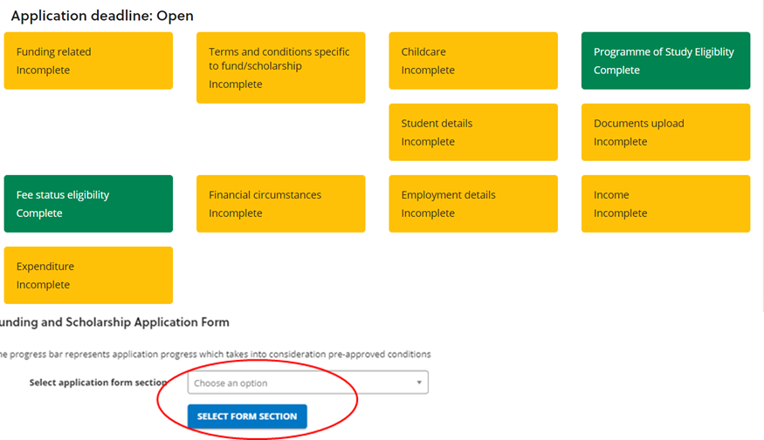
- You will see a screen with information about the Fund. Click the blue “Start Application” button at the bottom of your screen. You will see a screen with different sections that will be either green or yellow. You will need to complete all the yellow sections before your application can be submitted. Please note that to complete each section you do not click on the boxes at the top of the page but must select each section from the drop-down list below and then complete each section.

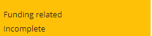
Funding related
Please select your answers from each dropdown menu. Each box must be filed out so if not applicable please put ‘N/A’. Once completed, press the next button.
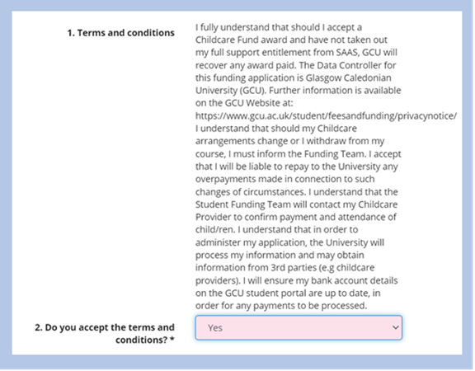
Terms and Conditions
Please read and select yes to confirm you understand and agree.

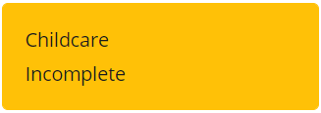
Childcare
Please complete all of the sections and note that the ‘Child(ren)'s names’ textbox has a 2000-character limit. For any sections which are not applicable please put ‘N/A’.
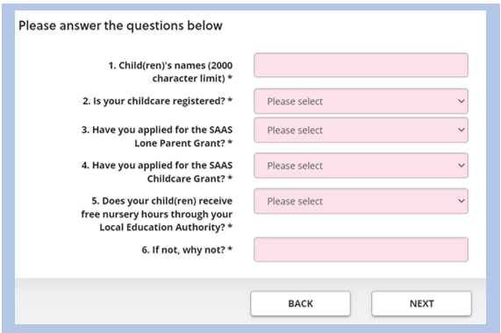

Student details
All Boxes must be completed. Once completed, press the next button.
Document Upload
Upload all documents relevant to you- Remember to click the ‘Browse My Computer’ and then the ‘Upload’ buttons to upload your documents successfully.

Essential Guidance on document uploading

Bank or credit card statements - you can download copies of bank or credit card statements as pdfs from most online banking accounts. Mobile apps sometimes do not give this option, so you may need to log into your online banking via a website, instead of relying on a mobile app.
Don't go from "current transactions" as this rarely produces a statement. Look for "statements" or go to historical transactions and go back three months. Statements (for example, something that "looks" like a posted version with name address, account details and so on) are only produced once every month so if you can't get one for this month, last month's will be there somewhere.
SAAS award letter - this can be downloaded as a pdf from your SAAS account. If you can’t find it and need to request a copy from SAAS, you can email SAAS asking for a copy of your 2022-23 Award notice. Whilst the SAAS email response says a response can take up to 28 days, students requesting an award notice usually receive this within a few days
Evidence of accommodation costs – this can be a copy of your tenancy agreement or, if you are living at home, a letter from the homeowner confirming the amount you pay in ‘digs’. Your tenancy agreement should show the address, your name, landlord’s name, dates of tenancy and monthly rent. A letter from the homeowner for ‘digs’ must have their name, signature and contact telephone number.
Timetable- Please provide a copy of your timetable for the current trimester. If you are on placement please provide a timetable or email confirmation of your placement days/weeks from the University or placement staff.
Carer Form- Part A of the Carer form must be completed by the childcare provider, Part B must be completed by the student. Please note that the Student Funding Team will contact all Childcare providers to check attendance, payment & validity of the information.
Carer Registration document- A copy of your Carer’s registration document must be provided or an official letter on headed paper from your childcare provider.

Financial Circumstances
For this section please fill out all the boxes. If questions 3 and 4 are not applicable to you then put ‘N/A’ and then ‘0’. For question 5 state in detail the circumstances which have contributed to your financial hardship. Please note this question has a 2000-character limit.

Employment Details
For not applicable sections enter n/a. The ‘hours’ section requires a number even if 0. For question 5
please state in detail the circumstances which have contributed to your financial hardship. Please note
this question has a 2000-character limit.

Income- Monthly

Please fill out all the sections- for any not applicable sections please enter 0 then next.
Expenditure- Monthly
Please fill out all the sections- for any not applicable sections please enter 0 then next.

Once all sections are filled out, they should turn green, as pictured below:
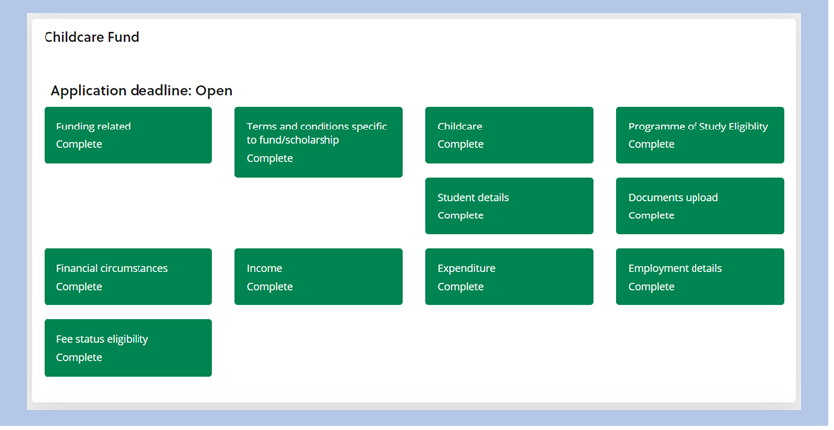

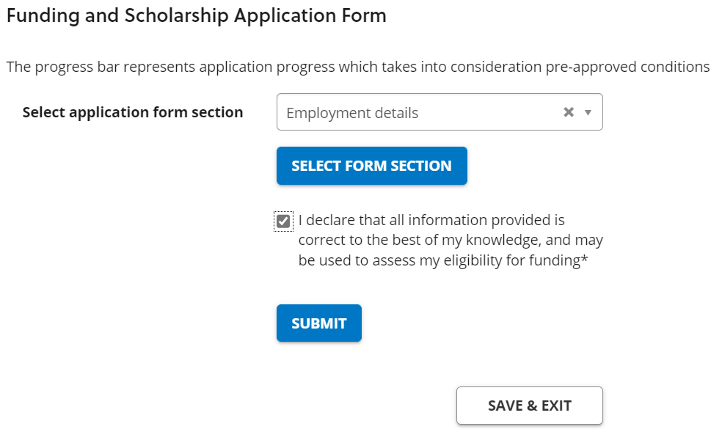
Final step Submit
Once all sections are green, please tick the declaration and then click submit and complete.
Please note that once submitted you cannot go back into your application.

You should then receive an email from the Funding Team, confirming receipt of your application.
Once received, the Funding Team will assess your application.
If there are any documents missing or we require further information, you will receive an email to inform you of this. Please follow the guidance in the email you receive on how to submit the required evidence/information.
If your application is successful, you will receive an email giving details of your award and an estimated timescale for you to receive payment.
If your application is refused, you will receive an email giving the reason for this refusal.

