Student guide to Podcasts

Table of Contents
Table of Contents 2
What is a Podcast 3
Podcasts within GCULearn 3

What is a Podcast
A podcast (combination of iPod and broadcast), is a method of broadcasting digital media (audio or video) via the internet. These files are usually episodic and can be downloaded and listened to/(viewed) on your computer, mobile device or portable media player. Podcasts provide an easily accessible platform and can be downloaded and listened to or viewed anytime/anywhere conveniently.

Podcasts within GCULearn
GCU Learn enables the creation of Podcasts which can be uploaded within a module for distribution. To download a podcast, open the course which contains the podcast, and navigate to the section which contains it, the module leader will provide information on the location of the link.
The page will open displaying the Podcasts which will normally have this icon beside it , Figure 1.
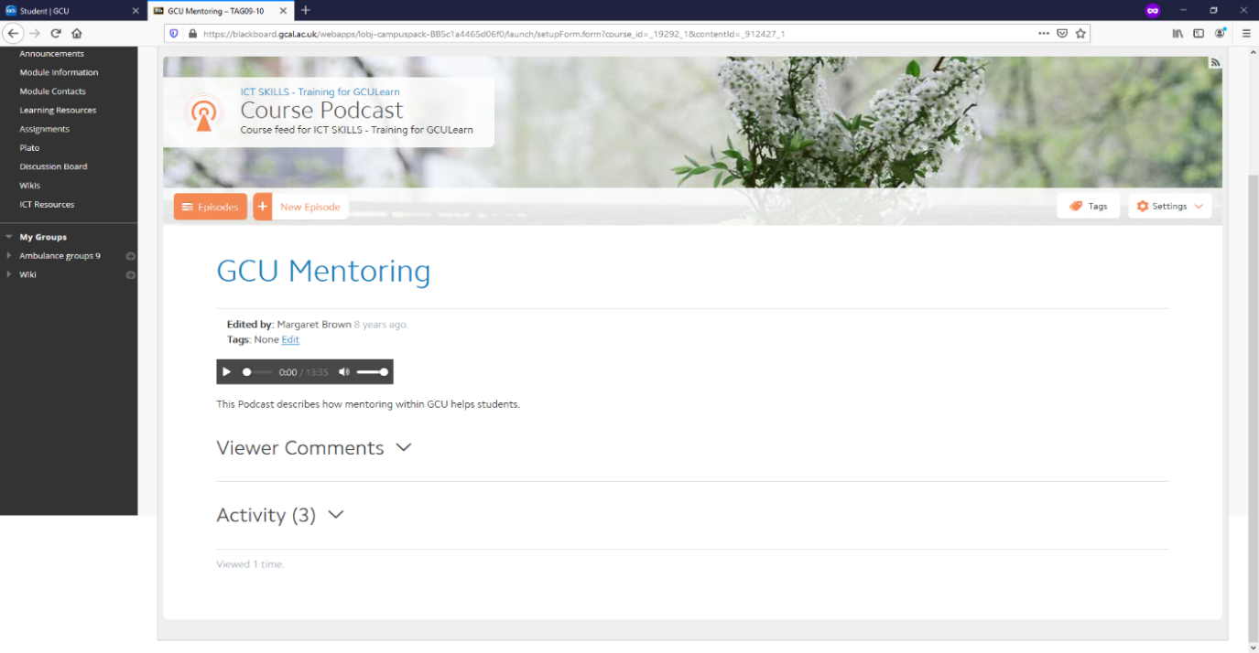
Play Controls
Podcast title
Comments and Activity menu
Figure 1: Course Podcast page
To listen to or download the Podcast click on the Play link, the podcast will open a media player and play.
You can comment on the podcast by entering a comment in the comment area. If there is more than one podcast you can use the links in the blue bar above the podcast name to move backwards and forwards to others.
You can also create Podcasts by clicking on the View button beside the Podcast name and clicking on the New Episode button. The New Episode Title field will be displayed, enter a name for the Podcast. The Create Episode dialogue box will be displayed. Add the information to the fields and click on the Save & Exit button, Figure 2.
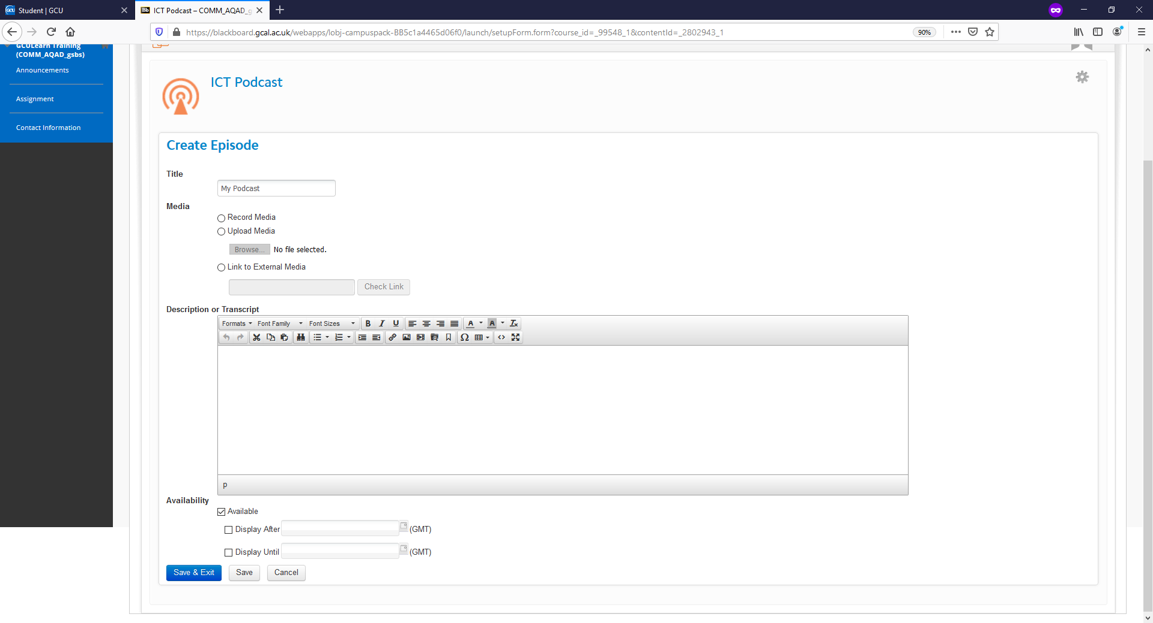
Title Field
Media Type
Descriptor/Transcript Field
Availability Options
Figure 2: Podcast Create Episode dialogue box

This work is licensed under a Creative Commons Attribution-NonCommercial-ShareAlike 4.0 International License.

