Students guide to Blogs

Table of Contents
Table of Contents 2
What is a Blog 3
Blogs within GCU Learn 3
To add a Blog Entry 4
The Blog Toolbar 4
Adding Images 4
Uploading a file 5
To Edit Information 5

What is a Blog
A Blog is an online diary or journal (the name derived from the words Web Log) and is normally updated on a daily or regular basis with information, images, news etc on a particular subject.

Blogs within GCU Learn
GCU Learn enables users to create private Blogs which are not available outside of GCU Learn. Depending on the settings applied viewing and commenting on the Blog may be restricted to yourself and staff on the module, or to certain groups within the module. Blog entries are normally displayed chronologically, most recent first ensuring that staff can easily view students’ progress.
To participate in a Blog in GCU Learn, click on the course link that has the Blog in it, the landing page for that course will open. Navigate to the section which contains the Blog by clicking on the button for that section, the module leader will provide information on the location of the link.
The page will open displaying the Blog will have this icon beside it, Figure 1.
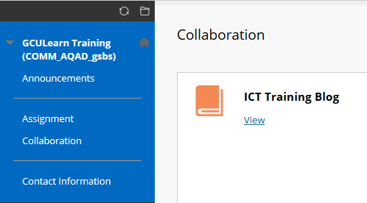
Figure 1: Blog in Assignments
To view the Blog, click on the View link. The Blog will open, Figure 2.
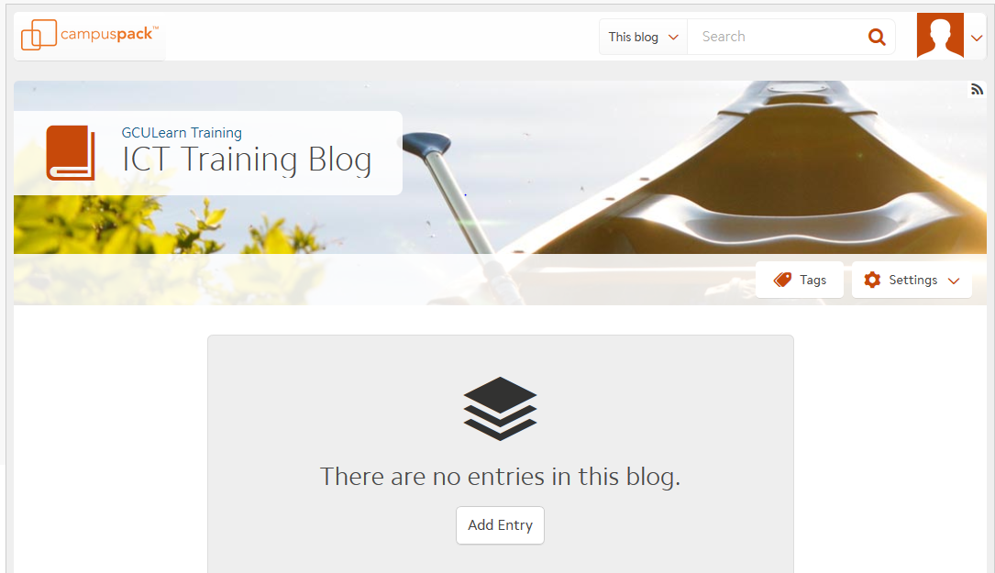
Blog Title
Add Entry button
Settings
Figure 2: Blog screen
Note: These sections can be customised by programmes and therefore may look different to that shown in the figure.

To add a Blog Entry
To add an entry to the Blog, open the Blog and click on the Add Entry button. the Add Entry page will open.
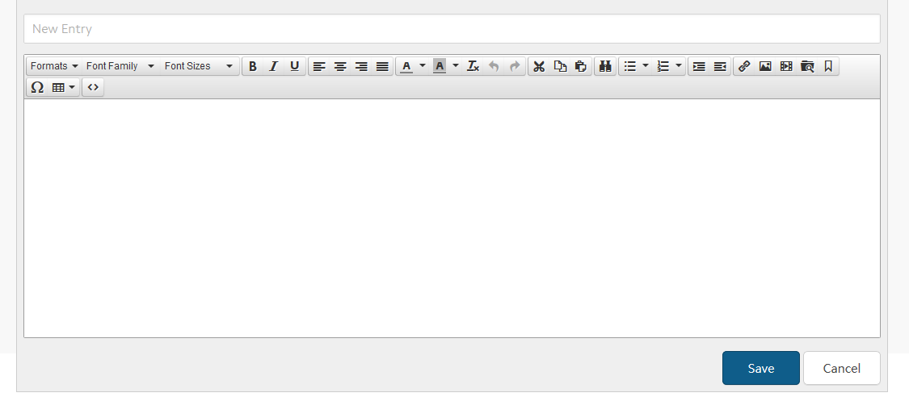
Add Entry field
Entry content section. Add text/images etc
Figure 3: Blog Add Entry page
To add your entry, type the title of the entry in the New Entry field at the top of the page and then add the information in the content field and click on the Save button.

The Blog Toolbar
The Blog toolbar allows content to be added to the blog, including the choice of font type, size and justification. Bulleted/numbered lists can be included and there are options to add links, images, video and files.
Figure 5: Blog Toolbar

Adding Images
To add images to the blog click on the Insert/Edit image command from the toolbar, Figure 6.
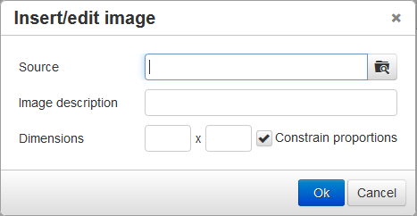
Figure 6: Insert/Edit image command and dialogue box
Navigate to the source of the image and insert. Add an image description and click on the OK button.

Uploading a file
Click on the upload file command from the toolbar, Figure 7
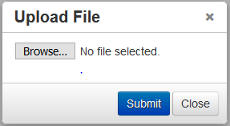

Figure 7: Upload file command and dialogue box
Navigate to the file and upload. Once uploaded click on the Submit button.

To Edit Information
If you wish to Edit the information contained within the Blog, navigate to the entry and click on the Edit button. The entry you wish to edit will open enabling you to enter your changes/addition.
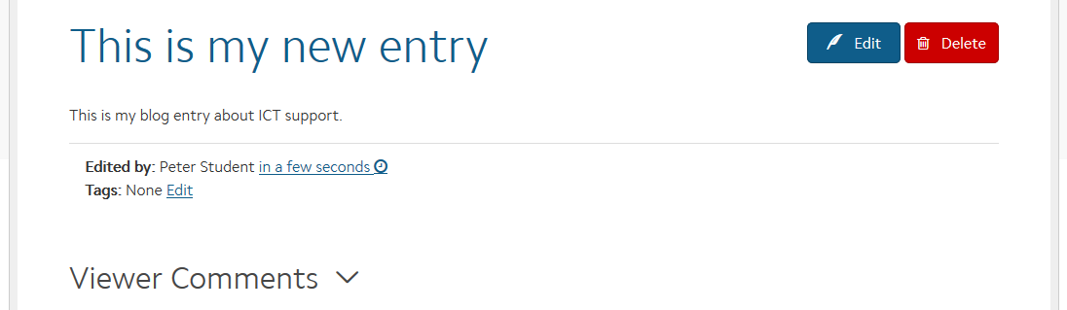
Edit button
Figure 9: Edit button
Note: REMEMBER – only one person can edit a page at the same time. Once you have entered your changes click on Save.

This work is licensed under a Creative Commons Attribution-NonCommercial-ShareAlike 4.0 International License.

