Finance Office
PECOS V15 User Guide
Reviewed July 2023

Contents | Page Number
Searching | 3
Creating Orders | 7
Cancelling orders | 12
Receipting orders | 14
Other FAQ’s | 16
Approver Training | 17
Returning an order | 17
Approving an order | 17
Approval delegation | 17
Adding New Users | 18
Adding New Approver | 19
Adding New User- Buy- For- profile | 20
Deactivating user profile | 24
Contact Procurement for Order Over £25k | 25

Searching

Using Parameter Search
- Click the Items tab to open the PECOS P2P Item Search page.
- In the section headed ‘Parameter Search’, select your supplier and search fields from the dropdown menus and enter key words in the ‘Contains the text:’ boxes.
- Click the Search button to locate all items matching your entered criteria. The search criteria section of the page will collapse and Search Results will display. Search results can be reviewed, filtered and sorted.
- Select one or more item by typing the desired purchase quantity in the Qty field.
- Click the Add button to add the item(s) to your Shopping Basket.

Using Quick Search
- Click the Items tab to open the PECOS P2P Item Search page.
- In the section headed Quick Search, type one or multiple key words for the item you are looking for, such as ‘toner’.
- Click the Search button to locate all items matching your entered criteria. The search criteria section of the page will collapse and Search Results will display. Search results can be reviewed, filtered and sorted.
- Select one or more item by typing the desired purchase quantity in the Qty field.
- Click the Add button to add the item(s) to your Shopping Basket.

Using Category Explorer
- Click the Items tab to open the PECOS P2P Item Search page.
- In the Left Navigation Panel click ‘Category’.
- To search for an item, scroll and select the appropriate category:
- Categories with an expand symbol indicate that they have additional subcategories. Click to expand the folder and open the next level of subcategory.
- Click the collapse symbol to collapse a category back one level.
- When the folder icons change into a document indicator icon this signifies that there are items coded to this category level.
- Clicking on the document indicator icon will invoke a search for all items that are coded to this category.
- Category search results will display.
- Review and optionally filter results and select an item by typing the desired quantity in the Qty field.
- Click the Add button to add the item(s) to your shopping basket.

Using External Market Place Search
- Click the Items tab to open the PECOS P2P Item Search page.
- In the Left Navigation panel click ‘External Market Place’.
- A list of external market places and PunchOut suppliers will display. Choose the supplier you wish to purchase from and click on the name.
- PECOS P2P will initiate a PunchOut to the selected site.
- In the external market place site, search the on line catalogue(s) and fill a shopping basket with the items you wish to purchase.
- Navigate to the completed shopping basket and if you are happy with its content and it is complete, return it (i.e. ‘check out’) to PECOS P2P (remember that each supplier site will have different formats and differently named buttons). The market place shopping basket is imported into a PECOS P2P Shopping Basket.

Using eForm Search
      - Click the Item tab to open the PECOS P2P Item Search page.
      - In the Left Navigation Panel click eForm Search.
      - A list of electronic forms will display. Choose the form you wish to attach and click the ‘Edit eForm’ link.
      - Download the form. This will happen automatically but you may find that a File Download Window opens. If this is the case click the open button.
      - Complete the form as required and save it in the normal way using ‘File’ and ‘Save As…’ in the top menu bar of the form’s application. Remember where you save it!
      - Click the Basket tab. You will notice that the eForm has automatically been added to your Shopping Basket as a line item.
      - The saved form can be attached to the basket line using the Comments and Attachments screen (see Comments and Attachments).

Other search information

Multiple Words and Boolean Characters
Multiple words can be entered to create a refined search. The Boolean characters of ‘and’, ‘not’ and ‘or’ can be used, with ‘and’ being the assumption between each separate word entered if a space is used. Words may be entered in any order. For example if the words: “toner black laserjet” are all entered (with a space between each word), PECOS P2P will search for all items that contain the word ‘toner’ and the word ‘black’ and the word ‘laserjet’ in any catalogue field for a single item. In this way it is possible to quickly find black LaserJet toner cartridges.
For example if the words: “white envelope not window” are entered (with a space between each word), PECOS P2P will search for all items that contain the word ‘white’ and the word ‘envelope’ but not the word ‘window’. This time our search results will contain all non window type envelopes that are white.
For example if the words: “black or blue” are entered, the search results will consist of items that contain either the colour black or the colour blue. In this way you are able to search for the correctly coloured items.
Note that the Quick Search is not case sensitive.

Wildcard Characters
A wildcard character of an asterisk (*) can be inserted at the beginning, middle or end of any word. This allows you to search using a partial text string where you are not sure of a spelling. The asterisk will be taken to assume ‘any character’.
For example, if the word ‘vacum’ is entered, PECOS P2P is unlikely to return any search results because it is incorrectly spelt. By using the wildcard character the text ‘vacu*’ can be entered. PECOS P2P will find all items that contain any word that starts with ‘vacu’. In this way we will be able to find all the vacuum cleaner related items in our catalogues.

Mixed Options
As you gather in confidence using Quick Search and get acquainted with your supplier catalogues you can begin to mix search options. Multiple words, Boolean characters and wild cards can all be used together to quickly find items.
For example, to find a box of formatted 3.5” diskettes manufactured by Sony we could enter the search text: “sony disk* not unformatted”.

Synonyms
This box allows for searches where different supplier’s terminology may differ slightly. For instance, if you are looking for “laptop” computers and your suppliers have listed these items as “notebook” or “portable” computers, the synonym search enables the system to recognise that “laptop”, “notebook” and “portable” may mean the same thing.
Each time any one of these words is entered in the Quick Search box, PECOS P2P will search for all of them: they have become synonymous with each other.

Spell Checker
This box allows PECOS P2P to find items even if the search criterion is misspelled. An example would be “xerographic paper”. A user who has the Spell Check box turned on who misspells this item as “zerographic” would still find the correct item. When the spell checker box is ticked PECOS P2P looks for an approximate match to the word(s) entered.

Create and save an order
Create an order with catalogue items
- Click on the Items tab and ‘Item Search’
- Search for your items and add them into your shopping basket.
- To add financial codes to your order click on the icon on the Requisition delivery and invoicing bar.
- Select the correct budget codes and click save.

Create an order with non-catalogue items
- Click on the Cart tab
- Click on the “Add Non-Catalogue item” button
- Click on the ‘Existing supplier’ function to choose your supplier.
- Enter the Item Number (if known), Estimated Price (unit price excluding VAT) and a Description (as detailed as possible)
- Click Add and Return once item has been added
- To add financial codes to your order click on the icon on the Requisition delivery and invoicing bar.
- Select the correct budget codes and click save.

Create a Recurring Requisition or Template order
- Create your order as normal but click on the “ save as template” button.
- From the drop-down list choose the type of recurring requisition you want to save or enter a new type in the adjacent box.
- From the group drop-down list choose the group you wish to have access to the recurring requisition, Private to only have access to it yourself, Glasgow Caledonian University to share it with every requisitioner in the university or your department to allow the other requisitioners in your department to have access to it.
- Enter a name for the recurring requisition and click on the “save” button.
- The screen will refresh and PECOS will display that the template or recurring requisition has been saved.
- To review the template orders click on the ‘templates’ tab.

Creating a Baxter Storey Catering Purchase Order
- Click on the Items tab and ‘Item Search’
- Select Baxter Storey from the drop-down list of Suppliers.
- Click on the search button to see the first page of the full catalogue. To browse through the whole catalogue, click on the next page triangle button on the top right hand corner.
- To narrow your search, enter your search criteria in the box then click on Filter.
- Once you have found what items you require, enter the quantity required in the Qty box on the left hand side of the line item. The quantity should be per person for tea/coffee etc
- Click on the add button either at the top left or bottom left hand side of the screen.
- The Items in Requisition at the top right hand corner will then update to show what you have in your current order.
- Click on the Cart tab or the Shopping Cart picture to access your order once you have added all items into your catering order.
- Once in your requisition click on the Paperclip icon to add an external comment to your order to provide delivery details etc.
- Click on External Comments
- A pop up will appear for you to enter your delivery details on, time, room number etc.
- **Please note that if there are attendees who are external to the university a list of those individuals should be included as an internal comment or as an attachment.
- Click on the apply comment button to save the comment onto your order. You will now see a Post-It next to the external comments button.
- Click the back button above where it says Internal and External Comments
- Click on the book with the magnifying glass icon to add your budget codes to the order. The secondary code should be 1032 – Hospitality Externals if there are externals present and 1034 – Hospitality No Externals if there are only staff and students present.
- Click on the Save button to save the codes
- Click Submit button to submit your order for approval

Creating a PECOS order number for travel/accommodation prior to confirming exact costs
- Create an order as per the previous instructions but add in estimated costs then submit without entering the budget codes.
- PECOS will then generate an order number but the order will not be routed for approval.
- Once the final costs are known from Clarity Travel, you can then access the order again through the ‘To do’ tab. Clicking on the PO Number will open the order.
- Then click on the edit button
- Click on the book and magnifying glass icon to update the Order Financial Tracking
- Select the appropriate primary, secondary and project code. If no project code is required the default project code will be ZZZZZ – Cost Centre. Click on the save button at the top of the page.
- Click on the submit edits button.
- Click on approve to confirm your changes to the order (NB – this is only to approve the changes, you are not approving the order)
- The order is then sent to the approver for authorisation.

Editing a system-returned Order
This section shows how to add budget codes to an order that the system has returned due to no budgets codes being applied. The system looks at the budget codes to determine which approver that order should be sent to.
- Either from the dashboard on the Home Page or the ‘To Do’ tab identify the order to edit.
- Click on the PO Number e.g. GCUXXXXX
- Click on Edit.
- Click on the FT code icon (book with the magnifying glass) on the top light blue ‘Order Delivery and Invoicing’ bar to apply the codes to the whole order as opposed to each line item.
- Select the appropriate primary, secondary and project code. If no project code is required the default project code will be ZZZZZ – Cost Centre
- Click Save.
- To apply codes at line level click on the FT code icon at the appropriate line.
- Select the appropriate primary, secondary and project code. If no project code is required the default project code will be ZZZZZ – Cost Centre.
- Click Apply to apply the codes to that line. The box above will display the updated codes.
- Click Save
- Repeat for all lines
- Click on Submit Edits
- Click on Approve to approve the changes you’ve made.
- The order will now be sent for approval.

Raising PO’s in PECOS via Buy-For Profiles i.e. GCUC/GCUA orders

There are requisitioners using PECOS who need to be able to place orders against both GCU and GCUC/GCUA budget codes. GCUC project codes begin with a K. GCUA project codes begin with a D.

Due to the configuration of PECOS workflows, requisitioners are unable to place orders against both GCU and GCUC/GCUA from their own user profile. Hence the creation of additional profiles for GCUC/GCUA called Buy-For profiles from which orders can be assigned for K/D project codes.
Therefore any purchase order that needs to be placed against a K or D project code should be created by changing to a Buy-For profile via the Requisition Delivery and Invoicing page in PECOS.

This can be done by following the steps below:

In the ‘Cart’ tab click on the “Requisition Delivery and Invoicing” link on the requisition header (pale blue bar).

On the ‘Requisition Delivery and Invoicing Screen’ click on the “User Lookup” button and click on the “Search” button on the Look Up Buy-For User Name and Address Screen

Select the Buy-For Profile for GCUC or GCUA by single-clicking on the ‘Select’ arrow next to the Buy-For User Name.

Click on the “Save” button on the Requisition Delivery and Invoicing Screen to apply the Buy-For profile to the order.

Secondary codes can now be applied through the financial tracking as normal.

Requesting a New Supplier
- Click on the ‘Cart’ tab.
- Click on the ‘Add Non-Catalogue Item’
- Under Supplier leave the ‘Unknown’ radio button checked.
- Enter the Item Number (if known), Estimated Price (unit price excluding VAT) and a Description (as detailed as possible)
- Click Add and Return once item has been added
- Once back in the Requisition screen click on the Paperclip icon.
- Click on the Internal Comments button
- Enter the company details in the Internal Comments box including full name, address, telephone number and email address
- Click Apply Comment
- Click on the Back button to go back to the Requisition page
- Click on the Financial Tracking icon
- Select the correct budget codes
- Click Save
- A pop up asking to reset VAT will appear, click OK
- Click on Submit to submit the order
- The order will now be submitted to Procurement to review and adopt the supplier.
- Click on the Order Number.
- The Audit Trail will detail that the order has been sent to Procurement for supplier validation.
- Procurement will advise if there is a more suitable contracted supplier that can be used, if not Procurement will look to adopt the supplier requested. The time taken to adopt a supplier is dependent on how quickly the supplier responds to the request to be adopted onto PECOS.
- When the supplier has been setup on PECOS, Procurement will return the order to the Requisitioner with the following instruction:
This supplier is now on PECOS Live: please follow these steps to progress order: 1) Click on Edit 2) Click on Supplier: Unknown (black underlined) 3) Choose supplier 4) Click Apply 5) Submit edits.

Cancel a Shopping Basket
Shopping Baskets can be cancelled before they are submitted as a requisition (i.e. during creation).
- Click the Basket tab to open your current shopping basket.
- Click on the Clear All button in the requisition header bar.
- PECOS P2P will ask a confirmation question.
- Click OK to delete all items in your basket.

No record is kept for any basket which is cancelled before it is submitted for approval and ordering.

Cancel a Requisition
Requisitions can be cancelled (i.e. after a Shopping Basket has been submitted) as long as they are pending approval in a requisition approval plan. Requisitions cannot be cancelled after purchase orders have been created.
- Click on the Documents tab to open the document search page.
- Enter search criteria to find the requisition you wish to cancel
- In the Document Search Results screen click on the requisition number of the requisition you wish to cancel. The Requisition Status Summary screen will open. Note that the order status of your requisition must be ‘Requisition requires approval routing’. If the order status reads: ‘Order requires approval routing’, the option to cancel will not be available since purchase orders have already been created.
- Click on the Cancel Requisition button at the top of the Requisition Status Summary screen.
- PECOS P2P will cancel the requisition and confirm with the text: ‘Requisition cancelled’, at the top of the page.

Cancel an Order during Approval
To cancel on Order Request after it has been submitted but before it has been approved and submitted as a Purchase Order to the supplier.
- Click on the Documents tab to open the document search page.
- Enter search criteria to find the order you wish to cancel.
- In the Document Search Results screen click on the order number of the order you wish to cancel. The Order Request Status Summary screen will open. The order status will display as ‘Order requires approval routing’.
- Enter your reason for cancelling the order in the comments and feedback text box. If you fail to enter comments PECOS P2P will display a warning message.
- Click the Cancel Order Request button at the top of the page.
- PECOS P2P will confirm cancellation by displaying the text: ‘Order has been cancelled’ at the top of the screen.

Cancel an Order after approval and after submission to supplier
- Click on the Documents tab to open the document search page.
- Enter search criteria to find the order you wish to cancel.
- In the Document Search Results screen click on the order number of the order you wish to cancel. The Purchase Order Status Summary screen will open.
- Enter your reason for cancelling the order in the comments and feedback text box. If you fail to enter comments PECOS P2P will display a warning message.
- Click on the Cancel PO button at the top of the screen.

PECOS P2P will create a zero value change order and transmit it to the supplier using the supplier’s standard order transmission method. The Purchase Order Status Summary screen will open.

Cancelling an Order & Copying to a new Order
- After cancelling your order, click on the ‘Copy’ button on the ‘Purchase Order Status Summary’ page. You will then be directed to the Requisition screen. Budget codes will be copied over with the order however these will only be visible in the Line Financial Tracking screen.
Please note that copying external marketplace orders is not recommended.
- Attachments/comments will not be copied over however you can save these from the previous order onto your desktop if you do not already have a copy saved elsewhere.
- The requisition can now be submitted for approval as normal.

Receipting

Searching for un-receipted orders
- Click on the Documents tab to open the document search page.
- Select ‘Find by Status’
- In the ‘Receipt Status’ drop down box, select ‘No items received’.
- In the Date Range change the start date to the date range that you wish query within.
- Click Find button
- This will then display any un-receipted orders for this given date range.

Receipting Orders
- Click on the Documents tab to open the document search page.
- Enter search criteria to find the purchase order you wish to receive.
- The Receipts screen can be accessed in one of two ways:
  - In the search results, click on the Receipt icon in the Actions column.
  - b. Click on the PO Number to open the Purchase Order Status Summary screen. Next click the ‘Receipt’ button at the top of the page.
- The Receive Items page will open for the order that was selected. The receipt form contains all the information that was on the original order to prevent you having to re-type any order information. Review the order details to confirm that you have selected the correct order.
- In the Receipt Detail section you must enter three mandatory pieces of information.
  - Delivery Note Number: (Goods Receipt Note or Packing Slip reference number).
    - This field is alpha-numeric
    - The number entered must be unique for each purchase order: i.e. each receipting action must have a different reference.
    - Maximum field length is 15.
    - If no delivery reference number is received the field may be left blank if the ‘No Delivery Note Number’ status is chosen.
  - Date Received:
    - Click on the date picker to open the calendar window. When the Calendar opens it can be incremented and decremented by month and year. To find a date in a month other than the current month, use the arrows in the upper corners of the pop up window to select the correct month and year.
    - Click on the date required to select it and the date will automatically populate the date field. Use the red delete icon to clear the date if you wish to make a change. The receipt date will be validated and future dates are not allowed. Enter a date that is either current (i.e. today) or past.
  - Quantity Received: Enter the actual quantity of items that have been delivered.
    - The quantity can be a decimal of up to six decimal places. (Note that decimal numbering must be enabled for your organisation.)
    - The quantity entered is not validated and may be greater or less than the quantity ordered (see Over Receiving).
    - It is possible to automatically allocate a receipt quantity by clicking the ‘receive all’ button. PECOS P2P will populate the quantity box for every line on the order with a quantity equal to the receipt balance remaining for the line. The receipt quantity is calculated as: Order Quantity less Received to Date.

Use the ‘receive all’ button when you have a few items on a large order that have not been received. Click ‘receive all’ and then change the non-receipted lines as an exception: remember all quantities are editable until you click the complete receipt button.

Other FAQ’s

Enabling Cookies through Internet Explorer

Click on the Tools menu

Click on Internet Options
- Select the Privacy Tab
- Click on the Advanced button
- Check the Override Automatic Cookie Handling box
- Check the Always Allow Session Cookies
- Click OK
- Click OK out of Internet Options

Approver Training

Returning an Order
As an approver within PECOS you can only approve or return an order to the requisitioner (person who raised the order). If you are unhappy about any aspect of the order return it to the requisitioner detailing the changes you wish them to make.
- From the PECOS Homepage you can access your orders for approval by clicking on the appropriate tab on the dashboard or by clicking the ‘to do’ tab.
- Click on the PO Number of the order to approve.
- Check the order through to make sure you are happy to approve the spend. The budget codes can be found by clicking on the book with magnifying glass icon
- To return the orders to the requisitioner enter a comment in the “Comments/Feedback” box.
- Click on the ‘return to requisitioner’ button.
- The screen will refresh and a message will be displayed that the Order has been returned to the Requisitioner.

Approving an order
- From the PECOS Homepage you can access your orders for approval by clicking on the appropriate tab on the dashboard or by clicking the ‘to do’ tab.
- Click on the PO Number of the order to approve.
- Check the order through to make sure you are happy to approve the spend. The budget codes can be found by clicking on the book with magnifying glass icon
- Click on the “approve” button.

How do I ensure my approval tasks are dealt with if I am out of the University?

Please complete the Approval Delegation Request Form and email to pecoshelp@gcu.ac.uk

Adding New Users
  - Adding a New User- Requisitioner
- Member of staff completes new PECOS user request form (this form is available on the website) http://www.gcu.ac.uk/financeoffice/procurement/e-procurementtools/pecos/ or on the shared drive - N:\Purchasing\PECOS\New User Requests)

- User must provide budget codes they require access to and signature from Head of Department on the form
- Click on the P2P Admin Button. This defaults to the Users tab
- Complete the user information as per the new user request form
- Use Copy button if existing colleague has same role/rights as new user
- Use Oracle ID plus @gcu.ac.uk as email address e.g. AG101119@gcu.ac.uk
- Preferred Payment Method = Invoice
- Select/Check Organisation Assignment
- Select/Check the following User Roles:
- Requisitioner
- Non-Catalogue Entry
- Receiver
- Punch-in User
- Select Address – this will auto-populate the Deliver To Name field
- Click on Add User
- Select the Groups and Roles tab
- Select/Check appropriate BRG (check a user profile of a colleague in same dept)
- (Note – requistioners can have access to more than one BRG)
- If BRG name not known for specific code, run Actuate Report within (see Section 12)
- Highlight main BRG and click on Set Default Accounting Code – ensure that User Default Accounting Code field is populated
- Always select **GCU Parent Group ARG in the Approval Rule Group dropdown list
- Click on Update
- Click on the Access Level tab
- Change the Order Access Level to the School or Department
- Change the Receipt/Return Access level to the School or Department
- Click on Update
- Add new user to the Users Info tab in the workbook - N:\Purchasing\PECOS\PECOS Workbook 2016\GCU Workbook 2015 GCU reviewed.xlsx
  - Adding a New User- Approver
- Member of staff completes new PECOS user request form
- User must provide budget codes they require access to approve and signature from Head of Department on the form
- Procurement check approver is on the Scheme of Delegation (SoD) and their approval level
- If not listed, inform staff member that HoD is required to submit updated SoD form to Management Accounting
- Management Accounting inform PECOS Help of updated SoD form

- Click on the P2P Admin button. This defaults to the Users tab.
- Complete the user information as per the new user request form
- Use Copy button if existing colleague has same role/rights as new user
- Use Oracle ID plus @gcu.ac.uk as email address e.g. AG101119@gcu.ac.uk
- Preferred Payment Method = Invoice
- Select Organisation Assignment
- Select the following User Roles:
- Punch-in User
- Input users name in the Deliver To Name field
- Select Address – this will auto-populate the Deliver To Name field
- Click on Add User
- Select the Groups and Roles tab
- Select appropriate BRG (may be useful to copy this from another approver within the department)
- Highlight main BRG and click on Set Default Accounting Code
- Always select **GCU Parent Group ARG in the Approval Rule Group dropdown list
- Click on Update
- Click on the Access Level tab
- Change the Order Access Level to user’s Department
- Click on Update
- Add new user to the Users Info tab in the workbook - N:\Purchasing\PECOS\PECOS Workbook 2016\GCU Workbook 2015 GCU reviewed.xlsx

  - Adding a New User- Buy For
Background:
- There are requisitioners using PECOS who need to be able to place orders against both GCU, GCUC and GCUA budget codes. GCUC project codes begin with a K. GCUA project codes begin with a D.
- Requests from users will appear in the PECOS mail box asking for access to K or D project codes
- Due to the configuration of PECOS workflows, requisitioners are unable to place orders against both GCU and GCUC/GCUA from their own user profile. Hence the creation of additional profiles for GCUC/GCUA called Buy-For profiles from which orders can be assigned for K and D project codes.
- Therefore any purchase order that needs to be placed against a K or D project code should be created by changing to a Buy-For profile via the Requisition Delivery and Invoicing page in PECOS.
Process for adding a Buy For User:
- Repeat Process for adding a new user (requisitioner) except:
  - User Name: GCUC or GCUA followed by dept: e.g. GCUC SHLS
  - User ID: GCUC or GCUA followed by dept (lower case): e.g. gcushls
  - Email address: pecoshelp@gcu.ac.uk
  - Org Level: or
  - User Roles: choose 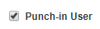
  - Select Address – this will auto-populate the Deliver To Name field

  - *Choose & move to
  - Add to
  - * See further section 9 for adding a new BRG
- Select User Profile who has requested access to this Buy For
  - for Buy For User using GCUC or GCU Academy as criteria:
  - Click to move Buy For User to Buy-For Users box
Amending Current users

Password reset
- Click on P2P Admin. This defaults to the Users tab.
- Enter name of the staff member requiring the password reset in the User Name field and click on Search
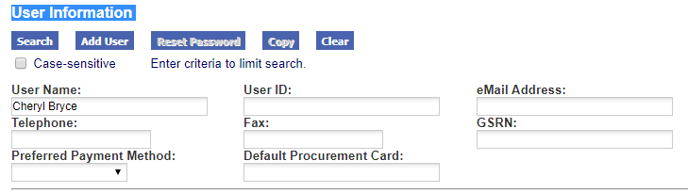

- Select User from User List
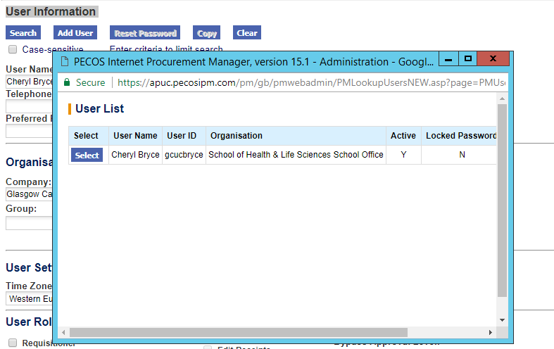

- Select Reset Password. System generates an emails containing a new password to the user
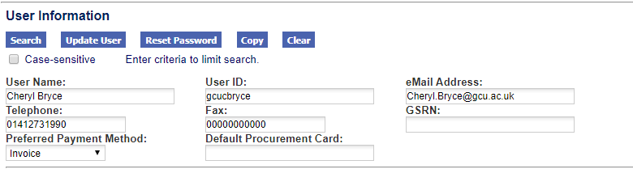

Approval Delegation
Approvers should set an approval delegation if they are going to be out of the office for a period of time.
- Approver sends email to PECOS Help instructing the approval delegation
- Click on P2P Admin. This defaults to the Users tab.
- Search for the approvers profile and then click on Approval Delegation
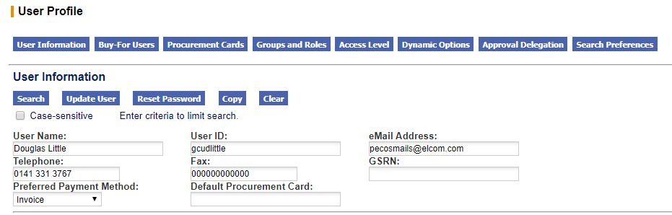
- Select Dates for Delegation
- Click on the calendar icon to set the Start Date: the date the delegation is to begin
- Set the End Date: this is the approver’s return date
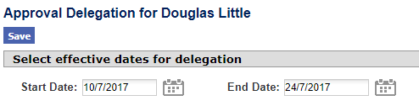
- Select a Delegatee
- Click on the user lookup button to open the user search screen 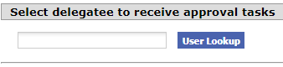
- Enter a partial value into the search box to refine the search and select if you wish to search by user name or user id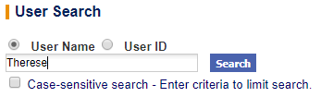
- Click Search
- A list of users who match your search will display. Click on Select to select one of the users and return to the approval delegation screen
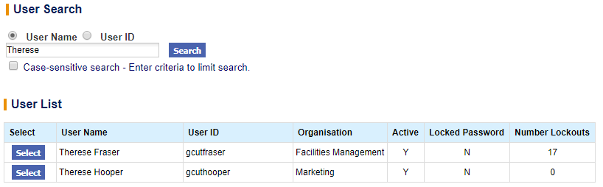
- Click Save
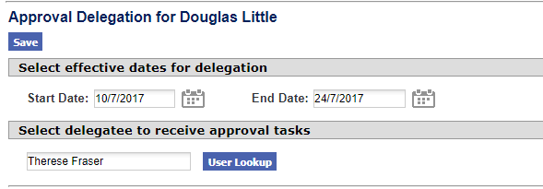

Delete a Delegation
- Navigate to the existing delegations box at the bottom of the Approval Delegation window
- Click the red X.

Note – A delegation cannot be edited. To alter an existing delegation, it must be deleted and re-created.

Outstanding Approvals

If delegations are not set by approvers, in order to avoid delays in the approval process, PECOS Help are also able to undertake approval reassignment and route the order to an alternate approver using the Outstanding Approvals function. This instruction will come from the requisitioner.
- Click on Outstanding Approvals
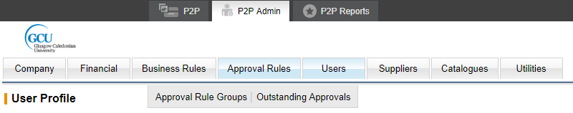
- Enter the original approver’s name in the Approver (Name/ID) (starts with) field
- Click Search
- Select the order/s and click Reassign
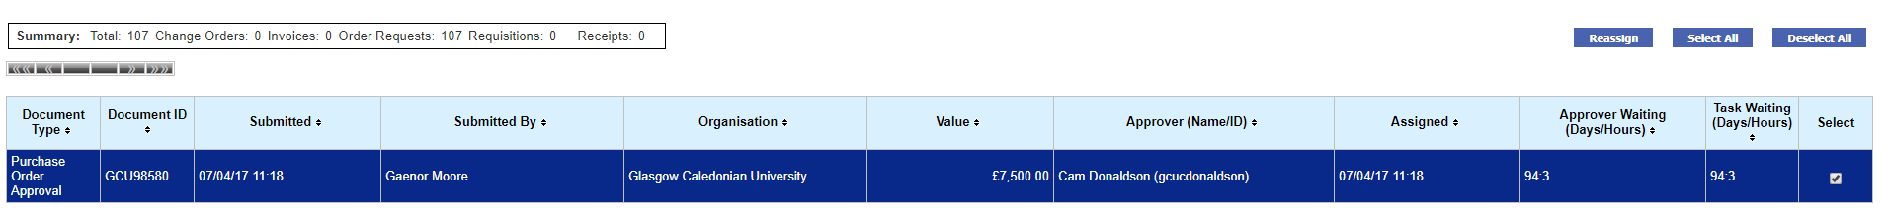

- Add name of approver named by requisitioner – ensure this person is listed in the Scheme of Delegation
- Add Comment (mandatory)

Deactivating current users

- PECOS Help receive spreadsheet from Payroll which details leavers, this is usually received on a monthly basis
- PECOS Help check requisitioner or approver status
- If Requistioner, user is made inactive on the system by clicking on the Inactive User radio button in the User Profile
- If Approver, PECOS Help provide all codes that this approver has access to and request replacement approver from HoD
- PECOS Help check Scheme of Delegation to see if member of staff is listed and their approval level
- If not listed, inform staff member that HoD is required to submit updated SoD form
- Management Accounting inform PECOS Help of updated SoD form
- PECOS Help update the relevant Approval Rule Groups, removing the leaver and adding the new approver – see section 2e for process
- The leaver is then made inactive on the system by clicking on the Inactive User radio button in the User Profile
- Update the workbook – If Requistioner, highlight deactivated user in red with comment on the User Info tab. If Approver, highlight deactivated user in red with comment on the User Info tab, update the primary codes tab if necessary, update the project codes tab if necessary.

Changing a user’s access
- If change is user moving cost centre
- Send request to HoD to approve change
- PECOS Help do changes on the system and update the workbook

- If change is user moving from requistioner to approver
- Send request to HoD to approve change
- PECOS Help check Scheme of Delegation to see if member of staff is listed and their approval level
- If not listed, inform staff member that HoD is required to submit updated SoD form
- Management Accounting inform PECOS Help of updated SoD form
- PECOS Help do changes on system and update the workbook
Contact Procurement for Order Over £25k
Procurement receive alerts for all PECOS orders over £25k. Requisitioners are advised to contact Procurement before raising over £25k orders to discuss procurement requirements e.g. Quotation exercise, Procurement Procedures Exceptions Form (PPEF) etc.

