EC10/4/1
Ethical issues involved in using Survey Monkey

Christina Knussen and Angus McFadyen, 1 November 2010,
Amended in October 2014

Online administration of surveys has many apparent advantages and is increasing in popularity. It is particularly attractive to those who wish to gain large numbers of respondents and to those who wish the respondents’ responses to remain anonymous. It is more acceptable to use a survey software tool, such as Survey Monkey, than to attach a questionnaire to email (see below), but a number of ethical issues remain. Survey Monkey is not the only survey software tool, but it is probably the best known at GCU. The technical points raised here relate specifically to Survey Monkey, but the ethical issues are probably relevant to the use of other software tools.

Anonymity
Responses can only be anonymous if the option to collect computer IP addresses is switched to ‘No’. The default is for this information to be collected. While designing the survey, the researcher has to go to ‘Collect Responses’, click on ‘Weblink’, which opens a list of options, then the researcher has to choose ‘show advanced options’ and click ‘Make anonymous’. Here the setting should be ‘Yes, make respondent data anonymous’. When this is chosen, a dialogue box appears in the top right corner stating that ‘the changes have been saved’. If the researcher revises the design of the survey, this option may revert to the ‘Yes’ default, and the researcher should be alerted to the need to check the setting of this question immediately prior to finalising the survey. Unfortunately, it does not seem possible for anyone other than the researcher to verify that IP addresses have not, in fact, been collected.

Confidentiality
Everyone who has access to a single Survey Monkey account seems to have access to the data from all surveys. It does not appear to be possible to protect certain surveys within a shared account by password. This means that data stored within shared Survey Monkey accounts (such as the shared GCU account) cannot be held confidentially.

Informed consent
It is not possible with Survey Monkey to provide an oral explanation of the study, or to take oral consent. This means that all of the relevant information must be given in the first ‘page’ of the survey or, indeed, on the email containing the link to the survey. This should follow the pattern of a paper-based information sheet, and cover the identity of the researcher(s), contact details, the reason for conducting the survey, the uses to be made of the data and so on. Warnings should be given if the survey covers potentially sensitive issues, and sources of further support and information should be given if warranted. Inclusion and exclusion criteria should be presented. The consent procedure also needs to be carefully considered. This can be addressed by presenting the items normally found on a paper-based consent form such that the items must be endorsed before the next page can be opened.

Right to withdrawal and omission of items
As a rule, no items (other than those relating to consent) should require a response. Respondents should be told that they can exit the survey at any point. However, they should also be told that they cannot withdraw any responses that have been made at the point of exit – if they wish to ‘erase’ their responses before exiting the survey, they need to backtrack through the survey.

Advantages and other issues
One of the key ethical advantages to using Survey Monkey or a similar software tool is that, if IP numbers are not collected, there is no way of tracing respondents. There is no need to use email addresses, and there is less likelihood of invading privacy (see BPS, 1997, p. 3). Further, it is likely that respondents will understand the uses that will be made of the data (including publication and other forms of dissemination), which is central to informed consent. However, it is not possible to verify identity in any way, and thus people who should be excluded from the survey (e.g., those under 16 years) may in fact complete the survey. Only minimal control by the researcher is available over access to and engagement with the material, and this must always be borne in mind. Finally, there is no guarantee that the responses will be equivalent to those that would have resulted from a paper-based survey.

Reference
British Psychological Society (2007). Report of the Working Party on conducting research on the internet: Guidelines for ethical practice in psychological research online. Available from
http://www.bps.org.uk/sites/default/files/documents/conducting_research_on_the_internet-guidelines_for_ethical_practice_in_psychological_research_online.pdf

A Practical Guide to turning off the collection of IP Addresses on Survey Monkey

When Creating the link to send out for your SurveyMonkey questionnaire you make sure that the settings do NOT collect IP addresses! This is done as follows:

- Click on ‘Collect Responses’
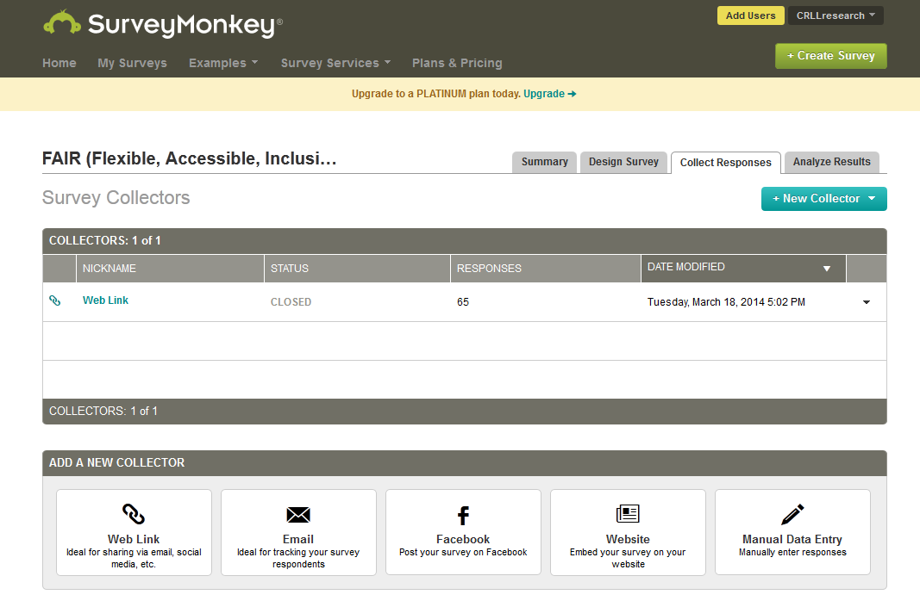
- Click on ‘Web Link’
- Then choose ‘show advanced options’
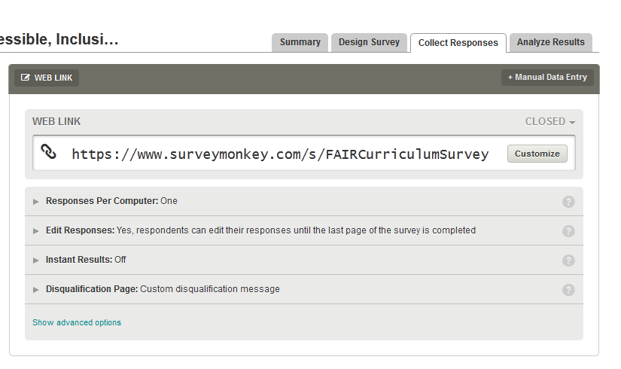
- Click on ‘Make Anonymous’
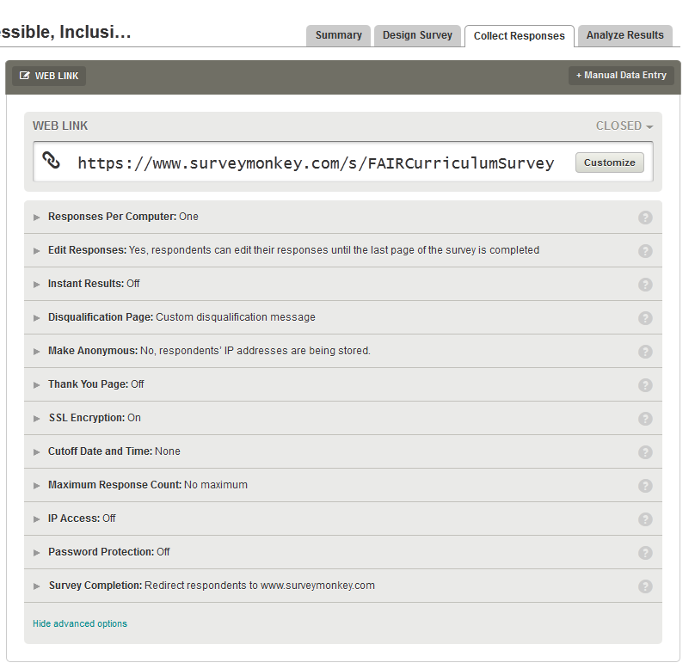

- Choose ‘Yes, make respondent data anonymous’.

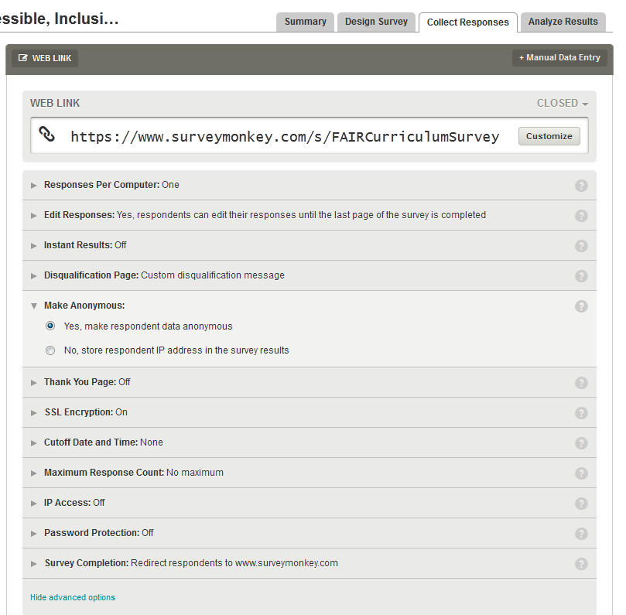

- A dialogue box will appear on the top right hand corner stating:

