**Accessible Technologies for remote working**

**Read and Write Gold – Temporary Access to Full Version for Home Use**

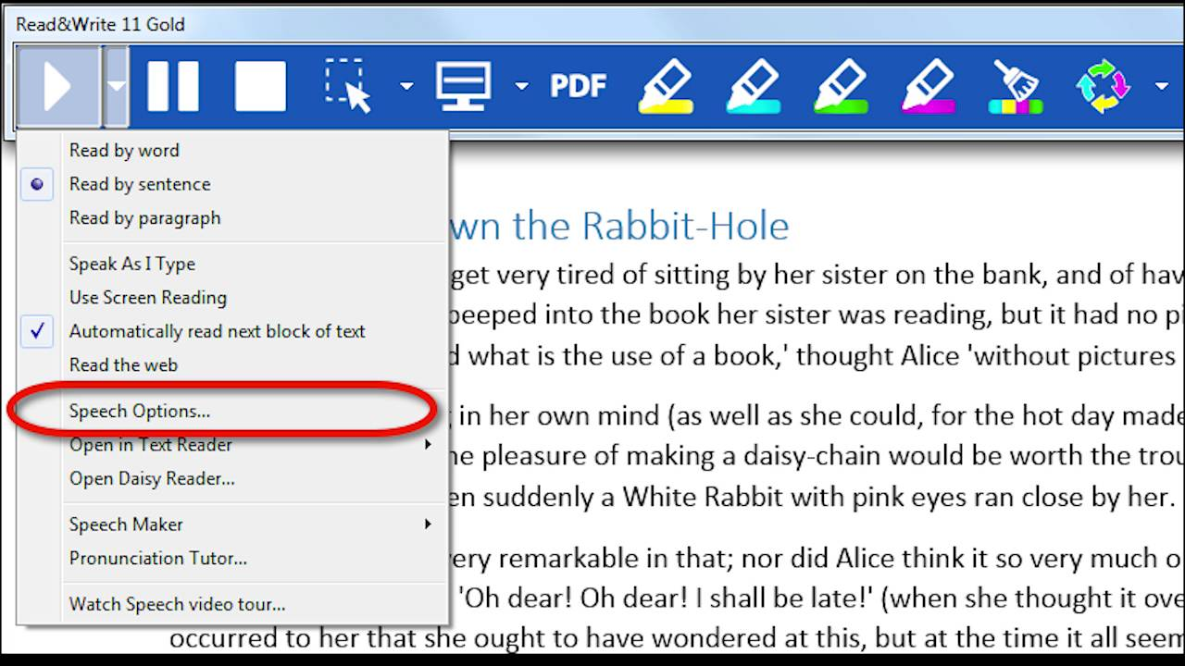

Texthelp have offered a temporary solution to allow students to access Read&Write remotely during this period of campus closure. It will allow you to continue to use Read&Write until the end of the academic year.

The instructional video below demonstrates how you can access Read&Write.

<https://youtu.be/xX-MYDaqppc>

You will need to activate this version with a special license code. You can get this here: <http://servicedesk.gcal.ac.uk/software>

**Read and Write Gold for Chrome or Microsoft Edge**

<https://www.texthelp.com/en-gb/products/read-write/>



There are browser plug-ins for Read and Write which you can access from home for free. You can choose the version you prefer, Edge or Chrome. There is no Firefox version at present. These browser plug-ins provide many of the same features of the desktop Read and Write software you might have used on university computers. To get the browser plug-ins for Read and Write, use the link above, click on “Choose your platform”, then select either Chrome or edge and choose “install”. Follow the instructions, and when prompted to log in with either a Microsoft or Google account, choose Microsoft and use your university email account.

**MyStudyBar**

<https://www.callscotland.org.uk/mystudybar/>

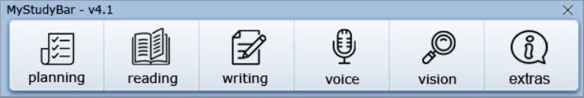

You can install MyStudyBar on your home computer to read text out loud, to check your spelling and grammar and to help you with proof reading. MyStudyBar is similar to Read and Write Gold, but is a little more basic. It is however free for everyone. To download MyStudyBar use the link above.

**Microsoft Word Inbuilt Read Aloud Features**

<https://www.gcu.ac.uk/student/support/induction/essentials/itguide/software/>

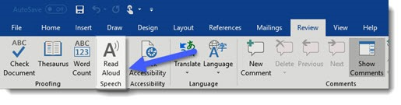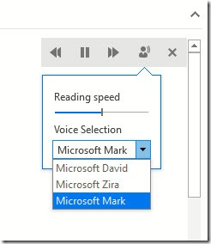

With your student subscription to Microsoft Office 365, you can use Word’s Read Aloud function to read any text in a Word document back to you. Just look for the “Read Aloud” command on the “Review” tab of the Ribbon.

When you activate this feature, you will see the panel above, where you can adjust options like the reading speed and the voice used.

**Mind Mapping on Tablets**

Mind Genius for iPad - <https://www.mindgenius.com/mindgenius-for-ipad/>

Simple Mind - <http://play.google.com/store/apps/details?id=com.modelmakertools.simplemindfree>

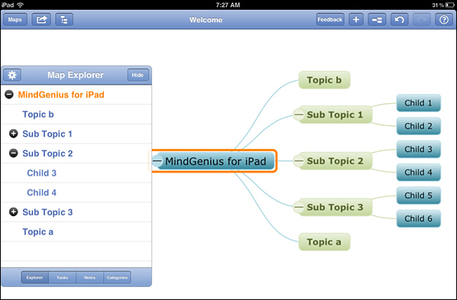

This is a very simple and quick version of the Mind Mapping software we recommend, enhanced with touch screen features to make it intuitive and quick to create a map. You can make a very simple Mind Map on your tablet or phone, then email it to yourself at the touch of a button and use it on the full version of Mind Genius later. At the moment this app is only available on iPads, but there is a link above for an Android app called Simple Mind which is similar

**Mind Mapping with Mind Genius**

<https://www.gcu.ac.uk/student/support/it/athomesoftware/>

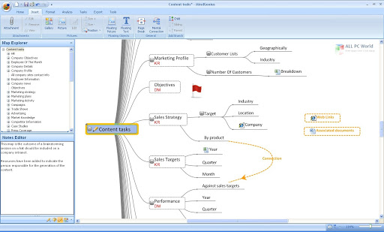

Mind Genius is the main mind mapping software we recommend at GCU. You can download it by following the instructions at the link above, and it is free for all students studying at GCU.

**Mac inbuilt accessibility features**

Read Aloud -[**https://support.apple.com/en-gb/guide/mac-help/mh27448/mac**](https://support.apple.com/en-gb/guide/mac-help/mh27448/mac)

Dictation -[**https://support.apple.com/en-gb/guide/mac-help/mh40584/mac**](https://support.apple.com/en-gb/guide/mac-help/mh40584/mac)

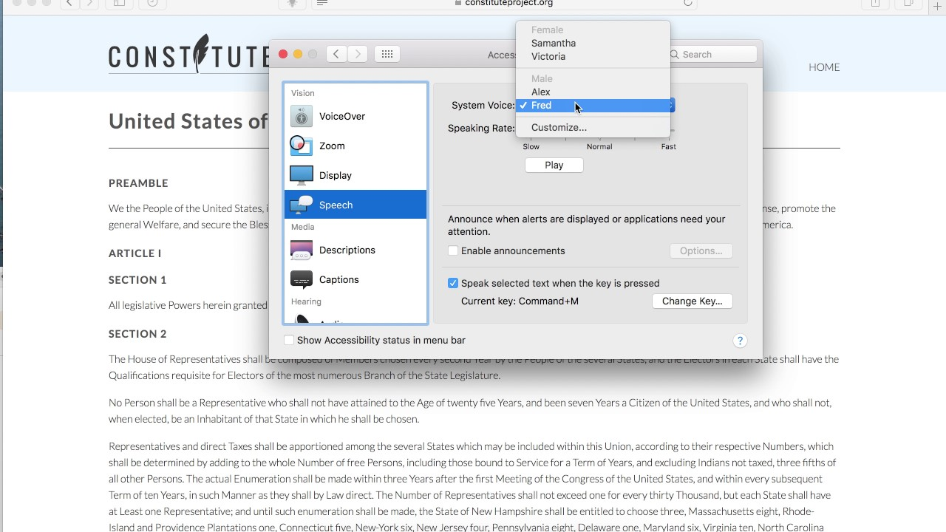

If you use an Apple Mac, there are some basic inbuilt features for both speech-to-text and text-to-speech. Click the links above for more information and instructions on how to get started with these features.

**Smartphone Read Aloud Apps**

For iPhone - <https://play.google.com/store/apps/details?id=com.renard.ocr&hl=en_GB>

For Android - <https://itunes.apple.com/gb/app/camscanner-free-pdf-document/id388627783?mt=8>

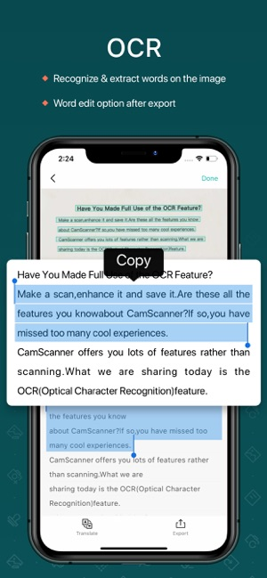 

The Apps linked above (*Text Fairy OCR* forAndroidand *CamScanner Free* foriPhone) will allow you to take a picture with text in it, and have that image converted to text that you can then edit, save, copy or paste or even have read out loud.