Student guide to MS Teams

Table of Contents
Table of Contents 2
What is MS Teams 3
How to Access MS Teams 3
Downloading to Desktop 3
Downloading mobile app 4
Activity 6
Chat 6
Teams 6
Assignments 8
Calendar 8
Calls 8
…More 9

What is MS Teams
MS Teams is an online platform used for communication and collaboration and is available within Office 365. Office 365 is the email platform currently being used by the University and therefore students will have access to Teams through this.
Note: Please REMEMBER to use your UNIVERSITY EMAIL ADDRESS TO ACCESS AND USE TEAMS

How to Access MS Teams
To access and install MS Teams go to http://teams.microsoft.com/download
The download MS Teams page will be displayed,
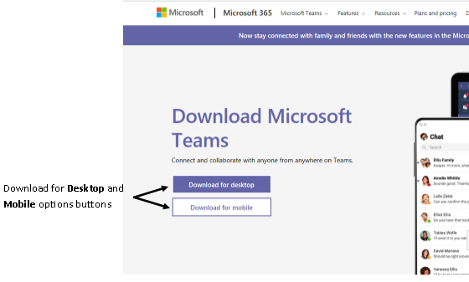
Figure 1: Download MS Teams page

Downloading to Desktop
To download to the desktop, choose this option and you will see the Download Teams for work on your desktop page. Click on the Download Teams button, the Save File dialogue box will be displayed. Choose Save File.
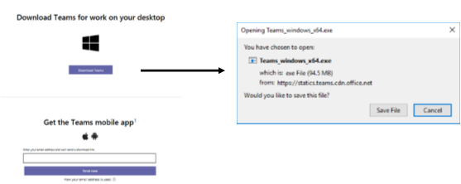
Figure 2: Download and Save File dialogue box

Downloading mobile app
To download the mobile App choose this option, enter your University email address in the field and click on Send now button.
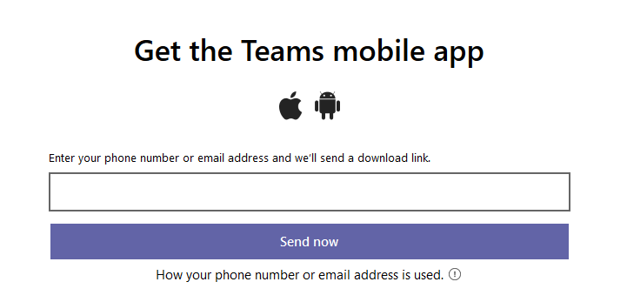
Figure 3: Get the Teams mobile app page
An email will be sent to the University email address provided. Go to your University email and open the message.
Note: Remember to check your Junk/Spam folders for the email
Within the email will be a link to download the app, click on this link, the Appstore will open displaying the Teams App. Click on the GET button to download on the mobile device. You may be asked at this point to login to approve the App download.
For desktop or mobile, once downloaded you will then be asked to sign in to Teams,

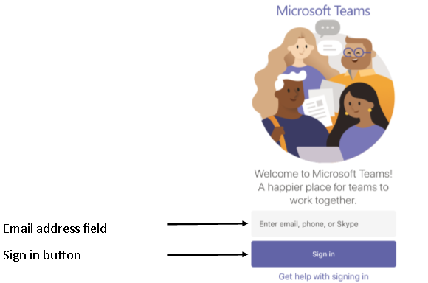
Figure 4: Microsoft Teams sign in page
Enter your University email address and click on the Sign in button. On the next screen enter your University password. The next few screens provide information on the types of activities that can be undertaken within Teams.
Figure 5: Getting Started with Teams pages
Click through these pages and then click on the Next button. Teams will then be displayed with the Teams toolbar on the screen.
Figure 6: Teams toolbar for students on a mobile device
Figure 7: Teams toolbar for students on a Desktop
There are various links within the toolbar to functionality. The functionality available will be determined by the organisation you are using Teams with and your role within it.

Activity
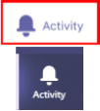
within Teams the Activity command will display two main pieces of information which are accessible from the drop down menu at the top of the page. It will show Feed and My Activity.
- Feed will show any alerts which have been made to your account.
- My Activity will show the history of conversations and activities in chronological order.

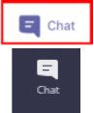
Chat
within Teams the Chat command enables one to one and group conversations to take place. To start a chat, click on the New Chat icon, the New Chat panel will be displayed. Enter the name or email address of the person(s) you wish to chat with and type your message in the Type a message field at the bottom of the panel. You can other media to the message using the tools in the panel.

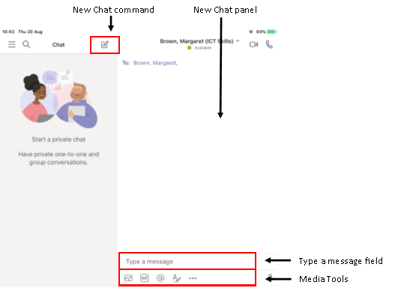
Figure 8: Chat within Teams

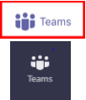
Teams
within Teams the Teams command allows you to see the Teams you have been added to within your organisation. You can also create Teams from here. Teams can be created for collaborative working with colleagues who share an interest, for example if you are working in a group for coursework a team could be created to facilitate this. To create a Team click on the Teams command.
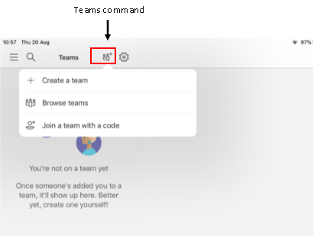
Figure 9: Teams page within Teams
Choose Create a team from the drop down menu. There are also options to Browse teams and to Join a team with a code.
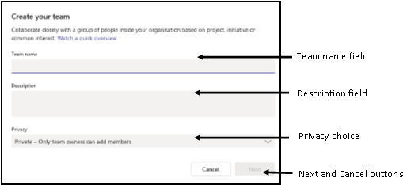
Figure 10: Create your team dialogue box
When the Create your team dialogue box is displayed, enter a Team Name, Description and Privacy option. Click on Next.
Note: Remember if you are working on anything with sensitive data you should ensure the Team is Private.
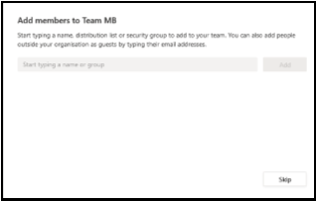
Figure 11: Add members to Team page
Add members to the team by entering their names or email addresses, you can also Skip this stage. Once done your Team will be created and listed within the Teams page. Team members will receive an email notifying them that they have been added to a Team.
Once a Team is created you can create Channels, these channels can be open to everyone and on a specific topic, or they can be to selected members. If within the group there was a sub group discussing one particular element of the group work, a channel specific to this could be created. To create a Channel, click on the Team to open.
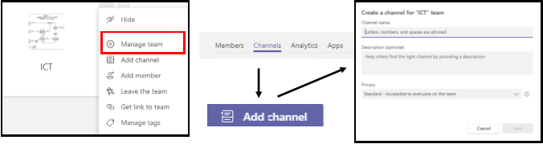
Figure 12: Channel creation within a Team
Once open click on the More ellipse… and choose Manage teams. From the Manage Teams page choose Channels, and then Add channel. When the Create a Channel for the team dialogue box opens add a name, enter a description and set the privacy options. If you choose the Private option, the Next button will be displayed. Click on Next and add the members.

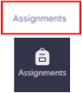
Assignments
within teams the Assignment link enables tutors who have created a class to create assignments and instructions which can be viewed by students. If you are not part of a class, you will not be able to view assignments.

Calendar
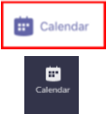
within teams the Calendar link allows you to view the Calendar and set meetings. To create a meeting within Teams, click on the New Event command on a mobile device or the New Meeting command on a desktop. The New Event/New Meeting dialogue box will be displayed, enter the Title of the meeting; Add the participants and set the time. Once you have entered all of the information click on Done to create the meeting on a mobile device or Save on a desktop.
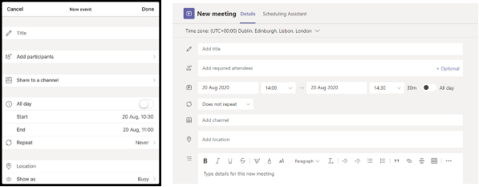
Figure 13: New Event/New Meeting in Calendar page of Teams
Once created the meeting invite will be sent to the participants listed.

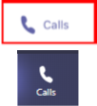
Calls
within teams the Calls link allows you to make calls. To make a call click on the Call command, the Make a call dialogue box will be displayed. Enter the name or email address of the person you wish to call.

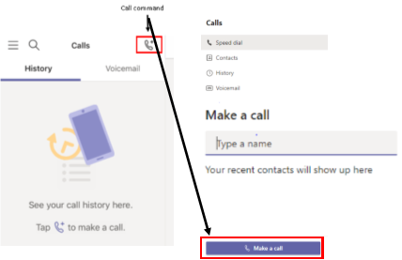
Figure 14: Call page within teams on a mobile device and on a desktop

…More
within teams the More link gives access to a further toolbar with functionality which may be useful for communication and collaboration.
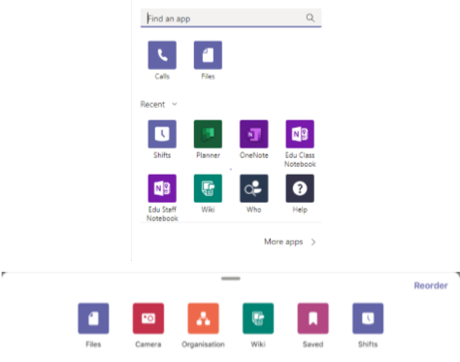
Figure 15: More toolbar within the More page of Teams on mobile device and desktop
The toolbar contains links to different items depending on the platform you are using, the main ones are:
- Files – the Files command allows access to files you have stored in your OneDrive account.
- Camera – the Camera command allows access to the Camera within your device for taking pictures.
- Organisation – the Organisation command allows access to the organisation, this view may not always exist for certain users.
- Wiki – the Wiki command gives access to a Personal Wiki viewer.
- Saved – the Saved command gives access to an area where saved discussions are kept.
- Shifts – the Shifts command gives access to an area where work shifts are scheduled.

This work is licensed under a Creative Commons Attribution-NonCommercial-ShareAlike 4.0 International License.

